FAMU-FSU College of Engineering
Department of Electrical and Computer Engineering

Project Proposal and Statement of Work
Date | Revision | Author | Comments
10/14/2014 | 1 | All | Original Document

ECE Design Team #: 3

Project title: Oil Spill Radar
Student team members:
− Stephanie Anderson, Electrical Engineering (Email: sa10h@my.fsu.edu)
− Omonayo Bolufawi, Electrical Engineering (Email: bomonayo@yahoo.com)
− Joel Watson, Electrical Engineering (Email: jsw08d@gmail.com)
− Eva Ulibarri, Electrical Engineering (Email: emu11@my.fsu.edu)
ECE Senior Design Project Instructor & Main Project Advisor: Dr. Michael Frank
ECE Review Members: Dr. Mark Weatherspoon
Team Sponsors: Dr. Oscar Garcia (FSU’s Earth, Ocean & Atmospheric Science Department)

Project Executive Summary

The Radar System for Oil Spill Analysis is a multi-year design project in which students from the FAMU-FSU College of Engineering will work to create a vertically actuated Radar System operating in C-band frequencies to aid FSU’s Earth, Ocean & Atmospheric Science (EOAS) Department in the study of Bragg scattering and Synthetic Aperture Radar (SAR). The system will help scientists and oceanographers study and interpret Bragg backscattering in regards to Synthetic Aperture Radar signatures in respect to varying levels of oil in simulated sea-state conditions.

The goal for the Fall 2014-Spring 2015 design team is to create a system that has the abilities to mechanically control independent Dual Polarity Dish antennae (transmitter and receiver) and accurately capture at least 50% of the transmitted signal in a portable, self-leveling and drainable wave tank using an aiming device. The antennae are being mounted and controlled independently (vertical actuation) by an intuitive mechanical interface in order to properly and accurately align the dishes to a degree in which the sponsors have specified. A wave generator capable of creating 2.8cm gravity style waves will be manufactured to ensure that an accurate return signal from the wave pool will be obtained. The circuitry is being made portable and weatherproof, as a number of extreme weather conditions are possible at the testing site. A graphical user interface (GUI) will be used to run experiments that sample the C-band electromagnetic wave-front’s scattering from the return signal.

The long-term goal of the system is to detect and quantify crude oil on the surface of simulated sea-state conditions through increased knowledge of SAR, although much more research and testing will need to be done before reaching this point. With the success of this project comes the potential for Florida State University’s EOAS Department to found a new area of research in the study of Synthetic Aperture Radar and Bragg scattering.
Table of Contents

Project Executive Summary ii
Table of Contents ii
1 Introduction 6
1.1 Acknowledgements 6
1.2 Problem Statement 6
1.3 Operating Environment 7
1.4 Intended Use(s) and Intended User(s) 7
1.5 Assumptions and Limitations 7
1.6 Expected End Product and Other Deliverables 8
2 Concept Generation & Selection 9
2.1 Linear Actuator Motion Control 9
2.1.1 Linear Actuator Motion Control 9
2.2 Wave Generator 12
2.3 Waterproof Components Case Design (two components) 13
2.3.1 Wood Waterproof Component Case 14
2.3.2 Plastic Waterproof Component Case 14
2.3.3 Component Casing Decision 14
2.4 GUI 14
2.4.1 Programming Language 14
2.4.2 Sampling Rate 15
2.4.2.1 MCP3008 Chip (Analog to Digital Converter) 15
2.5 X-Band System 16
3 Proposed Design 16
3.1 Overview 16
3.2 < Programming > 17
3.2.1 Database 18
3.2.2 Database Structure 18
3.2.3 Network Based Graphical User Interface (GUI) 18
3.3 < Linear Actuator Motion Control Code > 18
3.4 <Antenna Environmental Requirements> 20
3.5 <Antenna Power Requirements & Control Requirements> 20
3.6 <Wave Generator> 20
3.7 <Weatherproof Equipment> 20
4 Statement of Work (SOW) 21
4.1 Task 1: Project Management 21
Project Manager 21
Project Manager 21
Business Administrator 21
Financial Advisor 21
4.2 Task 2: <Raspberry PI Accessibility > 21
4.2.1 Objectives 21
4.2.2 Approach 22
4.2.2.1 Subtask 2.1: GUI Programming 22
4.2.2.1.1 Objectives 22
4.2.2.1.2 Approach 22
4.2.2.1.3 Test/Verification Plan 22
4.2.2.1.4 Outcome of Task 22
4.2.2.2 Subtask 2.2: Antenna Motion Control 22
4.2.2.2.1 Objectives 22
4.2.2.2.2 Approach 22
4.2.2.2.3 Test/Verification Plan 23
4.2.2.2.4 Outcome of Task 23
4.2.2.3 Subtask 2.3: Wave Generator Motion Control 23
4.2.2.3.1 Objectives 23
4.2.2.3.2 Approach 23
4.2.2.3.3 Test/Verification Plan 23
4.2.2.3.4 Outcome of Task 23
4.2.3 Test/Verification Plan 24
4.2.4 Outcome of Task 24
4.3 Task 2: <Weatherproof Component Case > 24
4.3.1 Objective 24
4.3.1.1.1 Approach 24
4.3.1.1.2 Test Verification Plan 24
4.3.1.1.3 Outcome of Task 24
4.4 Task 2: <Conversion to X-Band > 25
4.4.1 Objective 25
4.4.1.1.1 Approach 25
4.4.1.1.2 Test Verification Plan 25
4.4.1.1.3 Outcome of Task 25
4.5 Test Plan 25
4.6 Documentation 26
5 Risk Assessment 26
5.1 Scheduling Risk 26
5.2 Budgeting Risk 27
5.3 Technologies or Devices not completely understood 27
5.4 Unidentified requirements or constraints 27
5.5 Software Failure 28
5.6 Critical design features 28
5.7 Experimentation Risk 28
6 Qualifications and Responsibilities of Project Team 28
6.1 Qualifications 28
6.1.1 Team 28
6.1.2 Project Manager – Eva Ulibarri 28
6.1.3 Project Manager – Stephanie Anderson 29
6.1.4 Team Treasurer – Joel Watson 29
6.1.5 Lead Electrical Engineer – Omonayo Bolufawi 29
6.2 Responsibilities 30
7 Schedule 32
8 Budget Estimate 33
9 Deliverables 34
9.1 Reports 34
9.2 Design Review 34
9.3 Hardware and Programming 34
10 References 35

Introduction

Acknowledgements
The Radar System for Oil Spill Analysis team would like to thank Dr. Oscar Garcia of the Florida State University Oceanography Department (Earth, Ocean and Atmospheric Science Department) for the provided knowledge, time, funding and experience.

The team would like to thank Dr. Michael Frank from the FAMU-FSU College of Engineering for working as the Main Faculty Advisor and providing time, feedback and knowledge towards the project.

Problem Statement
This project will use a vertically polarized C-band antenna system and a wave pool area to study backscattering and interpret data using Synthetic Aperture Radar (SAR) to detect oil spills on the surface of water. There already exist two antennas (Transmit and Receive), cabling, circuitry and a semi-complete data collection system (Raspberry Pi) that needs to be implemented. The must-have end goals for the design team are to mechanically control the dual antennas vertical position using a wireless computer, build a user interface to analyze and collect data, view data results on an Oscilloscope GUI, and control a wave generator that has been built by previous design teams on this project. The wave generator should be capable of creating 2.8-cm (height) gravity-style waves and powered by the same power block in the existing circuit. All equipment will need to be weatherproof so there is no failure.

The desirables for this project would be to transform the antenna system from C-band (5.4 GHz) to X-band. This would require new antennas, new data collection ideas and changing the operating frequency.

Operating Environment
The Radar system will be primarily tested at the College of Engineering Senior Design Lab. All equipment has been set up for testing and once the project has been finalized, all equipment will be moved back to the Florida State University’s Oceanography testing facilities warehouse. The radar system will be mounted outside in Tallahassee, FL on a 30FT tower. Since the equipment will be officially tested outside it will be exposed to varying weather conditions, including temperatures between 20°F - 110°F, high to low precipitation, and windy conditions. All weather-proofing of all circuitry and mechanical aspects of the design is needed.

Intended Use(s) and Intended User(s)
The intended users of the Radar System for Oil Spill Analysis are the project sponsors (The Earth, Ocean & Atmospheric Science Department), members of the FSU Oceanography Department, student of future senior design projects and any faculty advisers who wish to test the system.
The Radar system’s intended use is to allow a means for FSU’s EOAS Department to study Bragg Scattering of SAR. The research is being done in order to find the best angle of incidence for determining the volume of oil emulsion on the surface of simulated sea-state conditions.

Assumptions and Limitations
The Oil Spill Radar team is under the following assumptions:
- The system will remain operable on C-band until all requirements are met.
- Once requirements are met, research and calculations can be done for transformation into X-band.
- The final product is for experimental purposes in the Oceanography department.
- The system will generate a gravity style waves in an existing wave pool.
- The system will control the angle of the antennas on the tower using a linear actuator.
- The system will use signal processing using a Raspberry PI to interpret the receive signal
- The system will remain portable and weatherproof.

The Oil Spill Radar team has the following limitations:
- The system must be protected from weather conditions and remain weatherproof.
- The team consists of four Electrical Engineering Students with limited programming knowledge.
- Hardware must run off of 5 to 12V rails or from a power outlet.
- The system will be constructed from last year’s design specifications.

Oil Spill Radar Team Project requirements:
Functional:
REQF-0001: Antennas must be mounted on a new mechanical arm that can be controlled from a laptop in the GUI. (CAP-004, CAP-005)
REQF-0002: The motion of the radar and antenna must have 30º range of motion powered by linear actuator.
(CAP -004)
REQF-0003: Integration of revised Analog/Digital Converter with Raspberry Pi Computer System. (CAP - 003)
REQF-0004: Design a GUI to collect data and operate wave pool generator and linear actuator. (CAP -003)
REQF-0005: Waves must be generated in a gravity style with a height of 2.8cm and of frequencies 0 to 5Hz. (CAP -002)
REQF-0006: Wave generator frequencies must be controlled from a laptop. (CAP -0002)
REQF-0006: Sampling rate (power and experimental readings) must be greater than or equal to 30 samples/sec.

Non-Functional:
REQN-0001: Circuitry must remain portable and weatherproof. (CAP–001)
REQN-0002: The programming languages used should be VHDL, Verilog, JavaScript, Python, or C++ and C. (CAP – 003)
REQN-0003: The radar needs to operate on C-band. (CAP-006)
REQN-0004: Optional – The radar needs to operate on X-band. (CAP-007)

Expected End Product and Other Deliverables
The Oil Spill Radar team will deliver to Dr. Garcia a fully operational Radar system to send and receive C-band radio frequencies to study Oil Spills using Bragg scattering and SAR. There is a possibility that the system will be delivered in X-band radio frequencies as per request of the sponsor. This deliverable will only be accomplished once all other requirements are met. The final project will be delivered in spring 2015.

The team will deliver two antennas mounted 30 feet up on an existing tower. The transmitter and receiver’s orientation will be controlled via the GUI, allowing the transmitting and receiving units to automatically adjust such that they are targeting the same location on the wave pool. The angle of the antennas will be controlled by a linear actuator and mounted to a side arm that supports the weight of the antennas.

The team will deliver a functional wave generator designed by last year’s senior design team. This year, the team will need to power and control the frequency of the waves generated. This will be controlled in the GUI environment and meet all specified requirements.

The team will deliver the capability of sampling the power and I/F signal at a rate greater than 30 samples/sec. This sampling rate was chosen based on last year’s senior design team’s specifications. The current A/D converter can still be used (sampling rate will be 200KSPS), however the script to acquire the data from the ADC must be rewritten completely since all data was lost using code software.

The team will provide the sponsor with deliverables and reports throughout the semester through group blog, website, and email for the remainder of the project duration.

Concept Generation & Selection

Linear Actuator Motion Control
The design for the linear actuator has been proposed and parts have been obtained. The team will need to assemble the antennas to the side arm and modify existing code for the electric component of the linear actuator. The code should be able to input the horizontal distance that the wave pool is from the tower, and using that input value, the antennae should adjust its aim to targeting the center of the wave pool. If either the transmitting or receiving antenna is not precisely aligned, the operator should be able to recalibrate the system by adjusting the transmitter or receiver’s position via the GUI. The electrical components of the linear actuator must be protected from the outdoor environment. A chassis will need to be designed to protect from all weather conditions.

Linear Actuator Motion Control
The Antenna Motion Control system will meet the following requirements:
- The motion of the radar and antenna must have a 30 degree range of motion.
- The desired angle of the antennas will be controlled in the GUI.
- The system must be protected from the environment.
- The antennas must target the wave pool.

In order to ensure that the system will operate at these requirements, the team will use previous year’s proposed linear actuator Figure 3 and the Pololu jrk 12v3 Arduino Board in Figure 4 based on the calculations seen in Figure 1 and Figure 2. The calculations below were performed to ensure that the linear actuator selected would in fact be able to both achieve the 30$°$ range of motion and control the load of the radar.

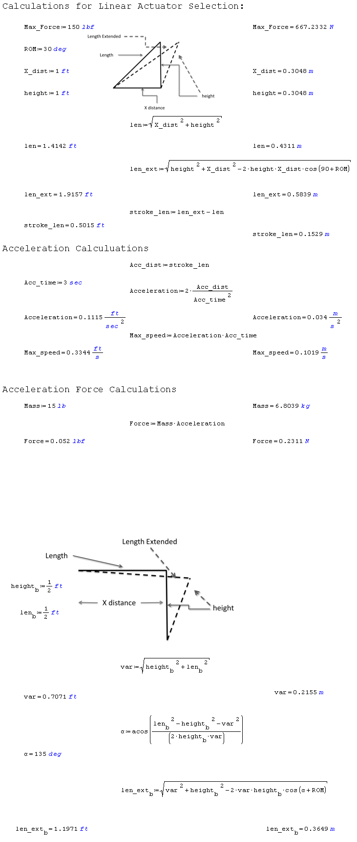
Figure 1: Linear Actuator Calculations

Figure 2: Linear Actuator Calculations

Figure 3: Linear Actuator for Antenna Motion Control
Figure 4: Pololu jrk 12v3

Wave Generator
A wave generator is needed in order to create waves with a height of 2.8 centimeters at a frequency of up to 5Hz. The waves must be gravity- or capillary style waves such as those generated from the interface of the ocean and the atmosphere. When the two fluid media interfere with each other, molecules in the water oppose each other and push the wave while each water molecule remains in the same spot along the longitudinal direction. The gravity style waves create a normal surface from which the radar signals can reflect to the antenna.
The team will need to make the wave generator functional at a user input frequency from 0Hz to 5Hz. The materials have all been assembled with a microcontroller.
The chosen gear motor for the wave generator is a 12V brushed DC shown in the figure below. This motor contains a 102:083:1 metal gearbox. The motor has a 0.61” long, 6mm-diameter D shaped output shaft. The motor selected allows the user to specify the angular frequency; the angular frequency is then translated to the rate of rotor rotations. This motor will generate waves in the longitudinal direction. This motor has the following features:

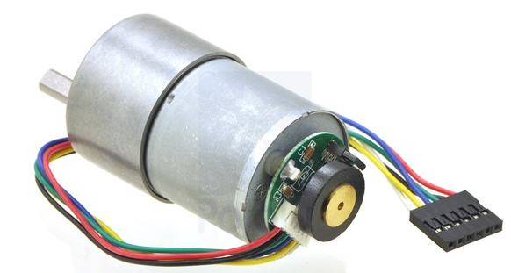
Figure 5: 100:1 Metal Gear motor 37DX57L mm from Pololu Robotics and electronics

- Gear ratio: 100:1
- Free-run speed at 6V: 50rpm
- Free-run current at 6V: 250 mA
- Stall current at 6V: 2500 mA
- Stall Torque at 6V: 110 oz. in
- Free run speed at 12V: 100 rpm
- Free run current at 12V: 300mA
- Stall current at 12V: 5000mA
- Stall Torque at 12V: 220 oz. in
- Lead length: 11in

The Electronic component of the motor is a Pololu Dual MC33926 Motor Drive Shield Arduino Board as seen in the figure below. The Controller can operate from 5 to 28 V. The Arduino Uno R3 board will be able to control the speed of the motor by changing the angular frequency.

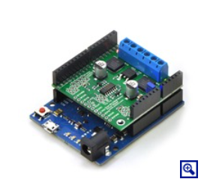
Figure 6: Pololu MC33926 Motor

The tasks that the wave pool generator will need to handle are as follows:
- The wave pool must be able to generate gravity style waves and/or ripples
- The frequency of the waves generated must range between 0 – 5 Hz
- The waves generated must be 2.8 cm
- The wave pool generator must be controlled from the GUI with the user providing an input frequency.

Waterproof Components Case Design (two components)
The Linear Actuator Arduino Board and the Wave Generator Arduino Board both are exposed to various weather conditions since their operation will mainly be outside. Leaving the equipment open will make it vulnerable to rain and wind and for thing reason, waterproof casing will need to be built. The dimensions for each case depend on the size of the Arduino board and holes will need to be made for the electrical cords to enter and leave. Below is a concept for what the casing will look like and ideas for waterproof
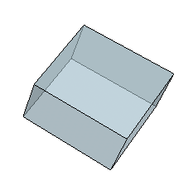
Figure 7: Waterproof Case Concept

Wood Waterproof Component Case
Wood is under consideration for the building of the waterproof casing. It is easy and inexpensive to use. Wood can also be manipulated for various sizes and easily machined with a density of 615 kg per meter cubed. The advantages are Cost: wood is a relatively cheap material. A 1.5ft in X 4ft X 8ft sheet of plywood can be purchased at home depot for only $15.95. This is enough ply wood to build the two small boxes. A disadvantage is that wood is not completely waterproof. It is very permeable and absorptive. Overtime these boxes would not be able to remain waterproof.

Plastic Waterproof Component Case
Plastic is another option for the waterproof casing of components. Plastic is moldable, cheap and easy and work with. The advantages are: it is strong with strength of 18 MPa, cheap: where it can be purchased for 28 dollars in a sheet which will be more than enough for both boxes, and it is weather resistant with no absorptive material. The disadvantage is that is not easily machined compared to wood. Plastic would have to be glued together to completely weatherproof the cases.

Component Casing Decision
Between wood and plastic for the casing of the Arduino boards the group decided to go with plastic. Plastic is cheap and completely waterproof compared to wood. Plastic is also stronger, cheaper and lightweight. The dimensions for the casing depend on the size of the Arduino boards. Development for the casing will be done by ordering a specific size with a company or cutting it ourselves and using glue to seal all parts.

GUI

Programming Language
The electronic equipment components communicate with the Raspberry PI to perform signal processing and analyze the receive signal. The ongoing process of coding from previous years (2012-2013, 2013-2014) project was lost and must be recreated. The design will follow similar designs from the previous years to communicate all portions of the circuit effectively. The computer system will utilize JavaScript or PHP coding language and sample code from the previous projects will be implemented to recreate the GUI.

Sampling Rate
A requirement of the system is to have a set sampling rate. The team will use the existing A/D converter that is capable of sampling at 150Mbps. This, in turn, will allow a more accurate understanding of the sampled wave signal, which will produce a more defined characterization of oil emulsion. The effective sampling rate will effectively store all the data

MCP3008 Chip (Analog to Digital Converter)
The MCP3008 Chip is the Analog to Digital converter that the 2012-2013 Radar for Oil Spill Analysis team utilized in order to enable an increase in sampling rate. The following are the specifications:
- This chip will add 8 channels of 10-bit analog input to the microcontroller or microcomputer project.
- Uses SPI so only 4 pins are required.
- Compatible with the Raspberry Pi Computer
- -40 to +85$°C$ temperature range.
- 200 KSPS sample rate at 5V
  - Advantages
- Accessibility: this device is in the team’s possession.
- Cost: Already in team’s possession
- Range of Temp: -40 to +85$°C$ temperature range.
- Compatibility: Functions well with the Raspberry Pi computer
  - Disadvantages
- Sample Rate: Sampling rate cannot be increased
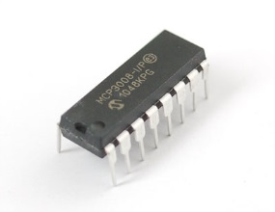
Figure 8: MCP3008 ADC
The A/D Converter to control the sampling rate was chosen to be the MCP3008 Chip. This is because the designers already have this component built into the circuitry and its functionality was proven in the. This component will help assist in the digital signal processing and data storage on the Raspberry PI.

X-Band System
Once all requirements are met in the C-band system, the team will start projecting ideas for the X-band system. At this level of the project, only low-level research will be going on for the upgrade. When everything is operational, power and frequency calculations will be performed and replacement parts will either be scoped out or ordered in relation to the status of the project.

Proposed Design

Overview
The system currently operates on the C-band frequency of 5.4 GHz from last year’s senior design project. In the future, if all other needs are met, the system will be converted to X-band with the same signal processing technique using the mixer component. Ongoing research will continue for the X-band system as other tasks are being completed. This design team will focus on adding mechanical functionality to the system using a linear actuator proposed from last year’s design team, adding functionality to a wave generator to create 2.8cm amplitude waves, waterproofing all electrical and mechanical elements, and creating a Graphic User Interface (GUI) to view the receiver signal, control the wave generator and control the angle of the antennas. Below is a block diagram of the existing system.

Figure 9: Overall Block Diagram

< Programming >
All programming will take place on the Raspberry Pi Development Computer. This specific computer was chosen because every aspect of the computer is open source, it was used by last year’s design team, and has 1.2 GHz ARM Processor which is more than enough processing power than needed. The computer will be running Linux, as such all programming must be able to compile and run in this environment.
All scripts written must be able to run in a Linux environment. The actual user interface will be web based and run on an apache web server with PHP support. All data combined must be less than 14 Gigabytes in size, so a snapshot of the sampling will be done instead of storing all data. Below is an image of the Raspberry PI model:
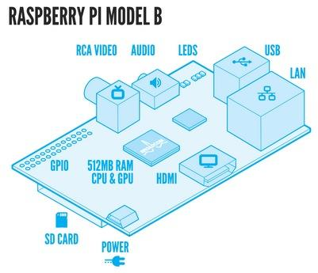
Figure 10: Raspberry Pi Model

Database
The MySQL database structure was chosen as the default database engine for this project. The database will store all data received from the DSP and be the engine for which the GUI generates its content. MySQL is currently the most used database engine available, and typically considered the standard database engine of the internet. It theoretically has infinite storage space so memory would not be an issue.

Database Structure
The sampling for the data base comes from the ADC and the chip chosen for the circuit. The samples are the amplitude of the analog signal converted into a string. The id variable is used for database purposes, and will help with storage.

Network Based Graphical User Interface (GUI)
Actual user interaction with the system will take place via a web browser designed from the previous year. The data for the system was lost and must be reformatted by access of IP address or by entering http://raspberrypi.local. The GUI will be written in PHP, JQuery, CSS, and HTML using MySQL as the database. This code language was chosen because there is sample code from the previous year to help rebuild the interface. When a user asks the GUI for updates a PHP script will query the database for new entries and return any if there is new data.

< Linear Actuator Motion Control Code >
The motor for the linear actuator was chosen from last year’s project. This year, the team must assemble and code the motor to perform at the request of the user. All drivers and files will be installed from the Pololu website specific for the Pololu jrk 12v3 motor controller. Once installed, functions will be written to control the motor up to an angle of 30 degrees to move the antennas. JavaScript, HTML, & CSS will be used to create the Motion Control GUI. The GUI (INPUT) will take in an X-value of the distance from the antennae to the wave pool. From there the code will calculate the degree needed for the antennae to be positioned to be aimed at the center of the wave pool. The angle will then be passed into the motor control function that will take an angle parameter. The motor control component will be written in C and will send a reformatted value to the pulse width modulator (PWM) to control the motor. The motor will then adjust the linear actuator to the angle desired. Seen in the figure below is a block diagram of how the system will operate and a visual of the movement for the antennas in the final simulation with all components assembled.
Figure 11: Block Diagram for Linear Actuator Code

Figure 12: Conceptual drawing of Linear Actuator Movement
The linear actuator will be assembled onto the wooden side arm created from the last year project and tested for movement from the code. Once accurate coding has been done, the antennas can then be mounted onto the side arm with the equipment the previous year had scoped out for the project. This equipment will allow the weight of the antennas and accurate control of the angle with the ability to withstand a dynamic load of 110 lbs. while moving and 500 lb. load while static.

<Antenna Environmental Requirements>
The antenna will be left outside exposed to the environmental conditions found in Tallahassee, Florida. The team must ensure that the antenna motion control mechanism will be robust and reliable since it will be exposed to heavy wind, rains, heat, and temperatures below freezing. The wind loads were handled by the calculations and further ensured by selecting a linear actuator that gave a significant margin of safety. In particular the LACT8P-12V-20 is able to withstand a dynamic load of 110 lbs. while moving and 500 lb. load while static. The electronic component will need to be protected by a weatherproof casing since it will be exposed next to the antennas 30FT above the ground.

<Antenna Power Requirements & Control Requirements>
Since the entire system must be able to operate within 12 or 5 Volt rails and be compatible with the Raspberry Pi applications processor, the linear actuator is to be powered via a jrk 12v12 motor driver. This was designed for similar linear actuators. It includes automatic motor driver shutdown on under-voltage, over-current, and over-temperature conditions, as well as many other built in features that will make the implementation of motion control quite easy. The current for each antenna is rated at 50 Ohms with a maximum power of 100 Watts. Refer to the spec sheet in the appendix for more details. The jrk 12v12 motor driver is designed to take a power input of 6-16 Volts. Given the high rail of 12 volts, the linear actuators and the motor drivers (5 volt signal input) work well together

<Wave Generator>
The motor for the wave generator was also chosen from last year’s project. This year, the team must code the Pololu Dual MC33926 Motor Drive Shield Arduino Board to generate gravity style waves in the wave pool at a specific frequency. The coding process is very similar to the way the linear actuator is embedded into the system as seen in section 3.3. The GUI will take in the frequency as an input. Then the code will be reformatted with the pulse width modular (PWM) to control the oscillation of the motor and generate the waves in the wave pool tank.

<Weatherproof Equipment>
The goal of the waterproof circuit case is to protect the electrical components from weather conditions, especially rain and dust which was one of the nonfunctional requirements. To meet this requirement the team will build a cubed shape case with dimensions slightly greater than the size of the Arduino boards. The casing should not be permeable and plastic was chosen for the design. This also meets our requirement for keeping all circuitry portable because plastic is lightweight and easy to manage and easy to transport.

Statement of Work (SOW)

Task 1: Project Management
Project Manager – Eva Ulibarri (Electrical Engineer)
- In charge of email coordination with advisors
- Partially manages and coordinates tasks of the group
Technical Responsibilities
    - Update team website
    - Hardware and Electronics
Project Manager – Stephanie Anderson (Electrical Engineer)
- In charge of scheduling presentations and booking rooms
- Keeps meeting minutes and records
- Keeps record of the project schedule
Technical Responsibilities
    - Knowledge of Antennas and circuit design
Business Administrator – Omonayo Balufawi (Electrical Engineer)
- Research implementation plans
- Keep track of all design documentation
Technical Responsibilities
    - Radar knowledge
Financial Advisor – Joel Watson (Electrical Engineer)
- Manages the budget
- Keep detailed records of all transactions
- Responsible for ordering and receiving parts
Technical Responsibilities
    - Hardware
    - Light programming

Task 2: <Raspberry PI Accessibility >

Objectives
The Raspberry Pi has a LAN connection output which is accessible through its own IP address. Previous year projects have set up a web browser interface using this process. The team will need to ensure the Raspberry Pi is still accessible through the IP address so coding can begin for the overall GUI running through a web browser using PHP support.

Approach
The team will hook up all connections for the entire circuit. Then, the team will follow the user guide provided by the previous year project to access the web browser. The guide provides troubleshooting techniques and diagrams to help the user ensure the circuit is set up properly.

Subtask 2.1: GUI Programming

Objectives
The overall objective of this task is to have a GUI that will display all data and results on a screen for easy reading in an internet browser. The data from the antennas, the controls for the linear actuator, and the controls for the wave generator will all be incorporated into one GUI. The architecture of the design should make it to where each individual system will work together easily within a web base and stored using MySQL.

Approach
The team will attempt to piece together sample code from the lost project and recreate the data base. Once the IP address is configured, the code for the GUI can be written. The team will start with the digital signal processing then move to the commands for the linear actuator and conclude with the commands for the wave generator all in one web browser.

Test/Verification Plan
As the project progresses, each section of code will be debugged and tested for the needed results. The programming language does not, in itself, need to be verified. Rather, the user interface must be intuitive enough that a user of typical knowledge and skill would be able to operate the GUI without needing a detailed explanation.

Outcome of Task
The outcome of the task is to be able to control the motion of the antenna using the GUI programmed with the chosen languages, read the receive signal, and operate the wave generator. The GUI should be intuitive and user friendly.

Subtask 2.2: Antenna Motion Control

Objectives
The development of the antenna motion control system is critical to the overall success of the project. The objective of the antennae motion control system is to accurately and independently control the aiming of the antennae to ensure that the sending and receiving units are properly aimed at the same location. The antennae must be able to sweep through at least 30$°$ of motion.

Approach
The design uses a Raspberry Pi which controls the angle of the antennas. JavaScript, HTML, & CSS will be used to create the Motion Control GUI. The GUI (INPUT) will take in an X-value of the distance from the antennae to the wave pool. From there the code will calculate the degree needed for the antennae to be positioned to be aimed at the center of the wave pool. The angle will then be passed into the motor control function that will take an angle parameter. The motor control component will be written in C and will send a reformatted value to the pulse width modulator (PWM) to control the motor. The motor will then adjust the linear actuator to the angle desired.

Test/Verification Plan
The first part of the antenna motion control is to mount the transmitting and receiving antennas onto the mechanical side arm designed from last year. The arm should be able to withstand the weight of the antennas during motion control. The other aspect of the test will be the motion of the antennas ensuring they can sweep 30 degrees and hold at a precise orientation. This will show that our approach for coding the motion is correct.

Outcome of Task
Once the above listed tasks are accomplished the Antenna Motion Control System will be fully functional and ready for data collection.

Subtask 2.3: Wave Generator Motion Control

Objectives
The objective of the wave generator is to create gravity style waves with a frequency between 0 and 5 Hz. The generated waves must have a height of 2.8 centimeters. The gravity waves will act as a normal surface in the system.

Approach
The design for the wave generator is already established and coding will need to be done for the oscillation at an input frequency. The wave generator using similar programming techniques as the antenna motion control because they are both Pololu brand Arduino boards. The GUI will read in a frequency inputted by the user and the motor control will be formatted into the PWM code. This will oscillate the motor and create waves in the wave pool.

Test/Verification Plan
One the code is written, the test will be to verify that the waves being generated are 2.8 centimeters in height. With the use of a ruler the user can measure 2.8 centimeters from the surface of the water and mark the spot.

Outcome of Task
When the task is complete, the team will have a working wave generator. The wave pool generator can now produce waves of 2.8 centimeters which will act as a normal surface for the radar signals to bounce back to the receiver.

Test/Verification Plan
When all parts of the GUI have been coded using the Raspberry Pi Linux environment, the team will hook up all equipment and test. Each section of the GUI will be tested for functionality and accuracy. The expected results should be obtained and any user should be able to access the web browser interface.

Outcome of Task
When all tasks and subtasks have been complete, the environment should be user friendly and able to provide and store data. This functionality will aid in the research of oil spills on the surface of water using an operational radar system.

Task 2: <Weatherproof Component Case >

Objective
The system will have to be tested outside and be able to withstand varying weather conditions. To protect the circuitry of the system from weather conditions such as rain, a protective case will be designed to enclose the exposed Arduino boards for the antenna motion control and the wave generator.

Approach
The approach is to design a simple cubed box to contain the electronic boards. Plastic was concluded to be the material used for our design for its cost, permeability, and portability.

Test Verification Plan
When testing if the boxes are weatherproof, they must be tested without any equipment inside. Ideas for testing could be a hose, a shower or any method to simulate rain. After about fifteen minutes, the boxes should be removed from the “rainfall” and examined for cracks or leaks. If the boxes are dry, the electronic equipment can be placed into their designed box and into the system.

Outcome of Task
When the boxes are completely tested, the team will have a waterproof case for the circuitry.

Task 2: <Conversion to X-Band >

Objective
Once the system components are operational in C-band, the sponsor requests for ideas and calculations for conversion to a X-Band system. The operational X-Band frequency requested is 91 GHz.

Approach
The approach is to come up to with calculations to examine which components will need to be replaced. The scoped out parts for replacements so far are a new local oscillator, a replacement band pass filter, new coaxial cabling and new antennas to operate at the frequency. The budget and final calculations will be performed near the end of the semester.

Test Verification Plan
No testing will be done on X-band. The testing will be calculations and scoped out equipment for operation. The digital signal processing will not change if all calculations are done correctly so for operational purposes, only the equipment would needed to be swapped out and tested for accuracy.

Outcome of Task
If all other tasks are met, the system will be able to perform in X-Band. If not, the research process will begin and next year’s senior design team could be tasked with this requirement.

Test Plan
When all requirements have believed to have been met, the system can be tested as a whole. The following sample procedure the team would follow:
- Clarify the system is fully operational is to plug in the circuitry and set up the test tank.
- Once the tank has been placed in the desired location level the tank.
- Confirm that the aiming mechanism is able to acquire data from the location specified in the GUI.
- Fill up the test tank.
- Add the substance that is being tested into the water.
- Turn on the wave generator and be sure it is generating waves of at least 2.8 centimeters to create a surface.
- Test and record the data gathered from the system.
- Ensure that the system is recording and storing data at the desired sampling rate.

Documentation
Documentation will occur at every step of the design process recorded in our lab notebooks. This includes ideas, prospected equipment, calculations or any errors that arise. With documentation the team will not repeat any errors and be more organized as milestones and tasks are completed.

Risk Assessment
In a project there is always some level of risk. If all risks can be identified, they have a better chance of being avoided. For the team project, there are a number of possible risks that could occur during the design, implementation, test, and experimentation phases. These risks include:

- Scheduling Risk
- Budgeting Risk
- Technologies or devices not completely understood
- Unidentified requirements or constraints
- Software Failure
- Critical design features
- Experimentation Risk

Oil Spill Radar team should actively try to prevent all risks from occurring. However, should any of these issues appear, the team should try to resolve them in a timely manner.

Scheduling Risk
When working in a group, it is important for the whole team to agree on a designated time and place to meet. An established meeting time is important in that each member can share any difficulties in a task. Also collaboration can be made for the final product. It is important to keep a regular schedule to ensure that members are not confused by inconsistent or sporadic meetings. Students have an ample amount of dwellings to work in so the setting should not be a problem. There is always a potential risk that the designated meeting area has been taken, so a backup location is an acceptable plan of solution. Group and individual deadlines should be addressed at the beginning of each meeting so procrastination won’t be an option. To maintain an efficient timeline of events throughout the project, students will follow the Gantt chart accordingly and assign other task if extra time becomes available.
There is also a risk of conflict in scheduling when members have additional exams to take care of in separate classes. It is critical to schedule time outside of the appropriated meeting time in case there is a need in other classes. The group can meet in smaller groups if other members are unavailable as long as proper notes are recorded for the rest of the members.

Budgeting Risk
The budget is critical in planning the development of the project. The project’s budget should not exceed the allotted amount to ensure the sponsor is satisfied. To ensure that the project is successful, the team must display a working C-band radar system before any commitment to developing an X-band system is taken. A repertoire of all parts needed to create the C-band system should be developed to ensure multiple parts aren’t ordered. As this is an on-going project many of the items have already been purchased through previous design groups. This report will eliminate any accidental purchases. To minimize any other budget issues, the team should work to buy quality products at an affordable price, keep a detailed record of all purchases. In case additional funds are needed, the College of Engineering will have funds available upon request within the allotted budget.

Technologies or Devices not completely understood
It is important for team members to have at least a basic understanding of how every technology or device related to the project works. Without any major programmers included in the project, the learning curve for team members will be low. Support and assistance will be offered from previous members of the design team to ensure that prior code will be used to the team’s advantage. Team members should educate themselves on code given, but are urged to keep master copy of all files. A master copy will keep the team from erasing or losing any of the necessary files. To create a well-balanced design team, each member should be assigned a specific piece of the project of which to become an expert. When each member feels comfortable in their knowledge about their specific part, steps should be taken to inform or educate the other team members in order for the whole to group to be familiar in all aspects.

Unidentified requirements or constraints
The design team’s primary goal is meet the requirements of the sponsor. The expectations of the sponsor should be addressed in the initial design process in order to abstain from working on secondary tasks that aren’t required and may affect budget costs.
The team should be held accountable for not meeting the specific requirements and constraints given by the customer. In the event that the sponsor has difficulty in identifying his needs, the best option is to verify all changes or projected changes with the sponsor directly before going any further. Members should be constantly communicating with the sponsor to get clarification at any time of confusion.

Software Failure
There is always a possibility of technical failures when it comes to demonstrating projects. Team members should make sure to keep a copy of the code on backup so that it can be reinstalled if necessary. To prevent software failure, excessive testing and debugging should be done during every stage of the project. Also, comments should left throughout the coding process to make debugging an easier process. Useful comments will help the team gather an understanding of each process to find any faults and resolve.

Critical design features
If the team finishes the project ahead of schedule, only then should they attempt to add in bonus functionalities, such as the X-band capability, to please the sponsor.
While working on the project, teams should try avoiding any unnecessary features detrimental to the success of the project. The team should get a well-defined structure from the customer on what features are needed to meet their expectations.

Experimentation Risk
There is high probability of risk during experimentation due to the experimental nature of the project. These risks include designing an experiment with a specific set goal in mind, but don’t then finding out after extensive testing that the steps were not properly followed to ensure that the goal was met. Another risk includes not being able to develop an experiment to prove a certain theory or hypothesis. Proper time management and planning is crucial in the experimental phase, as it is always possible to ask for clarification or help from advisers or customers. However, if too much time has passed, the team’s dedication could come into question. Poor implementation of the circuitry by not properly connecting the required component in the appropriate place can impose an experimental risk.

Qualifications and Responsibilities of Project Team

Qualifications

Team
The members of Oil Spill Radar each are composed of qualifications for this project. The members have academic and technical abilities that all work together towards the goal of the project.

Project Manager – Eva Ulibarri
Eva is a fourth year Electrical Engineering student who will graduate from Florida State University in the fall semester of 2015. She has taken Digital Communications, Signals and Systems, Digital Logic, Electronics, and Introduction to C++ Programming. Currently, she is enrolled in Fundamentals of Power Systems, Microcontroller Based Design, and Solid State Electronic Devices. Her greatest interests are in power and electronic hardware but her knowledge in microcontroller based design will be of the most use to this specific project because of the Raspberry Pi controlled GUI.

Project Manager – Stephanie Anderson
Stephanie Anderson will be awarded a BS in Electrical Engineering and a minor in physics in the spring of 2015 from the FAMU-FSU College of Engineering. Stephanie has worked as an engineering intern for RCC Consultants for three years. The Florida Department of Transportation is a client of RCC specifically the microwave network on the interstates and turnpike. Stephanie has done technical drawings of towers, antennas, shelters and equipment racks. This internship gives her hands on experience with how a communication system works and what certain antennas are mainly used for. Stephanie started her college career as a Computer Engineering major taking classes such as programming 1, object oriented coding, Unix, and discrete math. Programming wasn’t enjoyable and switched to Electrical Engineering. The Electrical Engineering course load has given her the qualifications for senior design and for this project. Stephanie is tasked with compiling meeting minutes, keeping communication with the group and scheduling in the group.

Team Treasurer – Joel Watson
Joel Watson will be awarded a BS in Electrical Engineering and a minor in physics in the spring of 2015 from the FAMU-FSU College of Engineering. Joel has a strong background in programmable logic devices and circuit design. He has previous experience working with FPLDs while employed at PolyPack Inc. as an intern. Joel has a minor background in programming and hopes to develop his skills while working throughout this project. Joel will be responsible for managing all budgetary needs and will remain in contact with any vendors necessary to continue with the project. He will also use his logic controller expertise to assist with developing and updating the wave generator and linear actuator arm. Joel is also familiar with programming languages such as C++, C, HTML. VHDL, and assembly language. Joel plans to pursue a career in engineering entrepreneurship and apply innovative and efficient designs to real world applications.

Lead Electrical Engineer – Omonayo Bolufawi
Omonayo Bolufawi , a fifth year physics and electronics student from FUTA (Federal University of Technology Akure) Nigeria now in FAMU- FSU college of engineering will be awarded a Bachelor of Engineering in the Electrical Engineering Department .He is knowledgeable on Telemetry systems like Radar systems and its applications. He has experience in the internet networking industry especially in the installation of LAN, WAN, VSAT, Fiber optics cable and deployment of internet facilities. He has some theoretical knowledge on electromagnetic field and waves. He has no knowledge of coding but his ability to learn will not limit the impact on the project. Omonayo will be responsible for research implementation and keeps record of the design documentation.

Responsibilities
The following is a table of member responsibilities.
Task Name | Engineer Assigned
Milestone 1 | 1,2,3,4
Milestone 2 | 1,2,3,4
Milestone 3 | 1,2,3,4
Access Raspberry PI Data Base | 1,2
Set up system in Senior Design Lab | 1,2,3,4
Read Receive Signal on Oscilloscope | 1,2,3,4
Research and Design for X-Band System | 2
Motion Control Code Development for Linear Actuator | 4
Test Linear Actuator Movement | 1,2,3,4
Purchase Longer USB Connection | 3
Weather Proof USB Cable | 4
Create Weatherproof Case for Linear Actuator Chip | 1,4
Create Interface for Control of Linear Actuator | 2,4
Mount Antennas onto Arm | 1,2,3,4
Test movement of Linear Actuator with Antennas | 1,2,3,4
GUI Layout Design | 1,2
GUI Code | 1,2
GUI Implementation for Signal Processing | 1,2
GUI Testing for Signal Processing | 1,2,3,4
GUI Implementation for Linear Actuator | 1,2,4
GUI Testing for Linear Actuator | 1,2,3,4
Wave Pool Generator Code Development | 2,3
Wave Pool Generator Testing | 1,2,3,4
Wave Pool Generator Weatherproof Case for Arduino Board | 1,3
Wave Pool Generator GUI Implementation | 2,3
Final Design of GUI Testing with all parts | 1,2,3,4
Power calculations of X-Band System | 2
Circuitry Design of X-Band System | 2
Order Circuitry Parts for X-Band System | 2,3
Order New Coaxial Cables for X-Band System | 2,3
Order New Antennas for X-Band System | 2,3
Implement All X-Band Circuitry and Cabling | 1,2,3,4
Dismount C-Band Antennas | 1,2,3,4
Mount New X-band Antennas | 1,2,3,4
Test X-Band Results | 1,2,3,4
Reconfigure GUI Signal Processing for X-Band | 2
Mount Side Arm with Antennas onto Tower | 1,2,3,4
Test Entire System with Wave pool and GUI | 1,2,3,4

Key
Engineer | Label
Eva Ulibarri | 1
Stephanie Anderson | 2
Joel Watson | 3
Omonayo Bolufawi | 4

Schedule

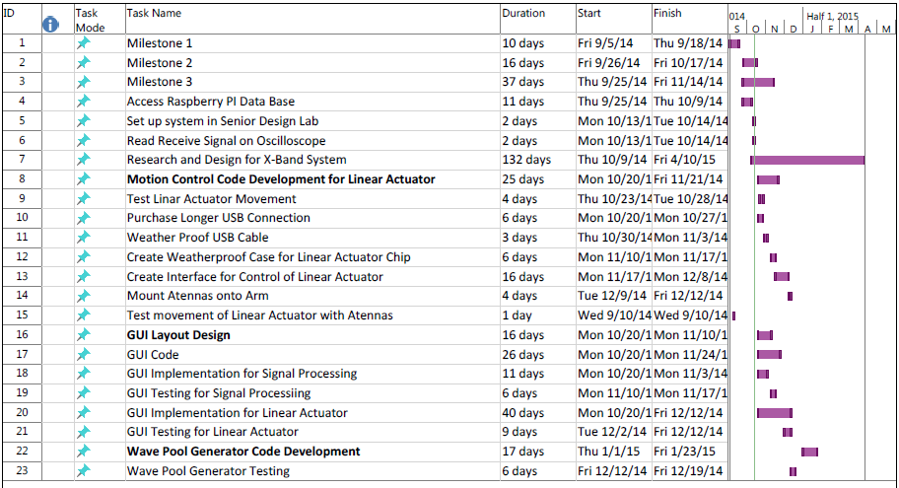
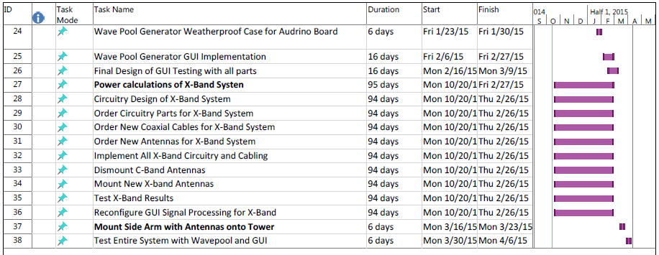

Budget Estimate

Assume the following for the Budget estimates
- Each engineer gets paid $30 per hour
- The total pay is based off of two 15 week semesters
- Fringe rate on all personnel is 29%
- Overhead rate is 45% of the direct costs

Engineers | Billable Hours | Hourly Pay | Total Pay
Eva Ulibarri | 360 | $30.00 | $10,800.00
Stephanie Anderson | 360 | $30.00 | $10,800.00
Joel Watson | 360 | $30.00 | $10,800.00
Omanayo Bolufawi | 360 | $30.00 | $10,800.00
Personnel subtotal |  |  | $43,200.00
Fringe Benefits |  | 29% of Personnel subtotal | $12,528.00
Total Pay |  |  | $55,728.00

Expenses
Items | Quantity | Per Unit | Total Price
Extension of USB Cable | 1 | $10 | $10
Plastic for Weatherproof Boxes | 1 | $28 per sheet | $28
 |  | Expenses Total | $38
Total Direct Costs |  | (Personnel + Expenses) | $55,756
Overhead Costs |  | 45% of Direct Costs | $25,090.20
Total Budget
Total Project Cost |  |  | $80,846.20

Deliverables

The completed project will be able to detect oil on the water’s surface. The antennas will send and receive C-band frequencies, which will detect the difference in consistencies of the surface, not the changes in motion of the water. Throughout the project there will be many deliverables including written and presented reports, design reviews, and programmed hardware.

Reports
The team meets with the sponsor and the advisor weekly to give undocumented oral reports and asks multiple questions. This is where most of the progress on the project is made. There are three official reports a semester to be delivered to the advisors. These reports are extremely detailed and keep the advisor updated with the overall progress of the project to date. The reports include detailed timelines and test plans for each of the tasks to be completed. This helps the advisor know where the team stands and if they are going in the correct direction to meet the expectations by the specified deadline. The deadlines are very strict because the students have to complete the project the end of the second semester.

Design Review
The team and project sponsor have weekly meetings where all progress is discussed and either corrected or approved by the sponsor. CMS has also provided helpful feedback and tips and helped to get the project working in certain programming aspects, since this is not the team’s strong suit. In the spring, there will possibly be a computer science student on the team, which will provide feedback and new ideas on how to make positive adjustments to the design and make the project goals more obtainable.

Hardware and Programming
The hardware for this project is already assembled and purchased. The system consists of a mechanical arm with mounted receive and transmit antenna, a fully assembled circuit to relay the information from the antennas to an oscilloscope, a Raspberry Pi to relay the data and information to a graphic user interface.

The programming delivered will be a fully functioning graphic user interface. This will allow the user to control the angles of antennas, the frequency of the waves, and to view the received data from the antenna clearly.

References
[1] "Pololu Dual MC33926 Motor Driver Shield for Arduino." Pololu Dual MC33926 Motor Driver Shield for Arduino. Web. 16 Oct. 2014. <http://www.pololu.com/product/2503>.

[2] Aguero, Manuel, Molus Marcelus, William Munch, Clifton Rice, Nolan Topey, and Nazarelle Vanputte. "Radar System for Oil Spill Analysis." EEL4911C Senior Design Milestone 2 (2013) (2013): 1-65. Print.

[3] Pololu, Kevin. "Pololu/dual-mc33926-motor-shield." GitHub. 6 June 2012. Web. 16 Oct. 2014.

[4] Logan, Jonathan, Juan Alvarez, Andrew Hale, and Roman Cooks. ECE Senior Design Project II. N.p.: n.p., n.d. DOCX.

