FAMU-FSU College of Engineering
Department of Electrical and Computer Engineering

SYSTEM LEVEL DESIGN REVIEW
Date | Revision | Author | Comments
11/14/2014 | 1 | All | Original Document

ECE Design Team #: 3

Project title: Oil Spill Radar
Student team members:
− Stephanie Anderson, Electrical Engineering (Email: sa10h@my.fsu.edu)
− Omonayo Bolufawi, Electrical Engineering (Email: bomonayo@yahoo.com)
− Joel Watson, Electrical Engineering (Email: jsw08d@gmail.com)
− Eva Ulibarri, Electrical Engineering (Email: emu11@my.fsu.edu)
ECE Senior Design Project Instructor & Main Project Advisor: Dr. Michael Frank
ECE Review Members: Dr. Mark Weatherspoon
Team Sponsors: Dr. Oscar Garcia (FSU’s Earth, Ocean & Atmospheric Science Department)

Project Executive Summary

The Radar System for Oil Spill Analysis is a multi-year design project in which students from the FAMU-FSU College of Engineering will work to create a vertically actuated Radar System operating in C-band frequencies to aid FSU’s Earth, Ocean & Atmospheric Science (EOAS) Department in the study of Bragg scattering and Synthetic Aperture Radar (SAR). The system will help scientists and oceanographers study and interpret Bragg backscattering in regards to Synthetic Aperture Radar signatures in respect to varying levels of oil in simulated sea-state conditions. The SAR’s return signal is characterized by the transmitted signal, surface roughness, electrical properties, and material composition of the water. Surface oil dampens the gravity waves responsible for radar backscattering and also enhances reflection from the underlying water. Reduction of the return signal amplitude, known as ‘Dark-Spot Detection’, is the result of reflection. Because Bragg waves are commonly 5.5cm for C-band frequencies, creating waves with amplitudes roughly half of the Bragg wave height (2.8cm) ensures a normal surface is present to reflect the electromagnetic waves back towards the Radar system (backscatter); a normal surface is crucial in order to distinguish between a clean, calm surface and one covered in oils and surfactants.

The goal for the Fall 2014-Spring 2015 design team is to create a system that has the abilities to mechanically control independent Dual Polarity Dish antennae (transmitter and receiver) and accurately capture at least 50% of the transmitted signal in a portable, self-leveling and drainable wave tank using an aiming device. The antennae are being mounted and controlled independently (vertical actuation) by an intuitive mechanical interface in order to properly and accurately align the dishes to a degree in which the sponsors have specified. A wave generator capable of creating 2.8cm gravity style waves will be manufactured to ensure that an accurate return signal from the wave pool will be obtained. The circuitry is portable and weatherproof, as a number of extreme weather conditions are possible at the testing site. A graphical user interface (GUI) will be used to run experiments that sample the C-band electromagnetic wave-front’s scattering from the return signal. The team has been able to host the files on a web server and set up preliminary testing for the GUI. The next step would be to rebuild the data base and verify all connections in the code work.

The long-term goal of the system is to detect and quantify crude oil on the surface of simulated sea-state conditions through increased knowledge of SAR, although much more research and testing will need to be done before reaching this point. With the success of this project comes the potential for Florida State University’s EOAS Department to found a new area of research in the study of Synthetic Aperture Radar and Bragg scattering.
Table of Contents

1 Introduction 6
1.1 Acknowledgements 6
1.2 Problem Statement 6
1.3 Operating Environment 6
1.4 Intended Use(s) and Intended User(s) 7
1.5 Assumptions and Limitations 7
1.6 Expected End Product and Other Deliverables 8
2 System Design 9
2.1 Overview of the System 9
2.2 Major Components of the System 10
2.2.1 Linear Actuator Motion Control 10
2.2.2 Wave Generator 10
2.2.3 Waterproof Components Case Design (two components) 11
2.2.4 Programming 12
2.2.5 X-Band System 12
2.3 Subsystem Requirements 12
2.3.1 Linear Actuator Motion Control 12
2.3.2 Wave Generator 13
2.3.3 Weatherproof Component Chassis 14
2.3.4 Raspberry Pi 14
2.3.5 Programming 14
2.3.5.1 Data Storage 15
2.3.5.1 Antenna and Wave Generator Motion Control 15
2.4 Performance Assessment 15
2.5 Design Process 16
3 Design of Major Components/Subsystems 16
3.1 Weatherproof Casing 16
3.1.1 Pololu jrk 12v3 16
3.1.2 Pololu MC33926 Motor 17
3.2 Linear Actuator Motion Control 18
3.2.1 Linear Actuator Motion Control Code 19
20
3.3 Wave Generator 22
3.4 Programming 23
3.4.1 Database 23
3.4.2 Database Structure 25
3.4.3 Network Based Graphical User Interface (GUI) 25
3.5 Analyzing the Data (Electromagnetic Waves) 25
4 Schedule 28
4.1 Responsibilities 28
5 Budget Estimate 30
6 Overall Risk Assessment 31
6.1 Technical Risks 31
6.1.1 Technical Risk 1: Software Failure 31
6.1.2 Technical Risk 2: Mechanical Failure 31
6.1.2.1 Technical Risk of Antenna Motion Control 31
6.1.3 Technical Risk 3: Electrical Failure 32
6.1.4 Technical Risk 4: Oil Hazard 32
6.1.5 Technical Risk 5: Technologies or Devices Not Completely Understood 32
6.1.6 Technical Risk 5: Access to Antenna Data 33
6.1.7 Technical Risk 5: Graphical User Interface (GUI) Failure 33
6.2 Schedule Risk 33
6.2.1 Schedule Risk 1: Component Shipment Times 34
6.2.2 Schedule Risk 2: Schedule Conflicts 34
6.2.3 Schedule Risk 3: Unfortunate Events 36
6.2.4 Schedule Risk 4: Resourcing Risk 36
6.3 Budget Risks 36
6.3.1 Budget Risk 1: Technologies or Devices Not Completely Understood 37
6.3.2 Budget Risk 2: Incompletely Identified Requirements/Constraints 37
6.3.3 Budget Risk 3: Under Budgeting 37
6.4 Summary of Risk Status 37
7 Conclusion 39
8 References 40

Introduction

Acknowledgements
The Radar System for Oil Spill Analysis team would like to thank Dr. Oscar Garcia of the Florida State University Oceanography Department (Earth, Ocean and Atmospheric Science Department) for the provided knowledge, time, funding and experience.

The team would like to thank Dr. Michael Frank from the FAMU-FSU College of Engineering for working as the Main Faculty Advisor and providing time, feedback and knowledge towards the project.

Problem Statement
This project will use a vertically polarized C-band antenna system and a wave pool area to study backscattering and interpret data using Synthetic Aperture Radar (SAR) to detect oil spills on the surface of water. There already exist two antennas (Transmit and Receive), cabling, circuitry and a semi-complete data collection system (Raspberry Pi) that needs to be implemented. The must-have end goals for the design team are to mechanically control the dual antennas vertical position using a wireless computer, build a user interface to analyze and collect data, view data results on an Oscilloscope GUI, and control a wave generator that has been built by previous design teams on this project. The wave generator should be capable of creating 2.8-cm (height) gravity-style waves and be powered by the power block in the existing circuit. All equipment will need to be weatherproof so there is no failure.

The desirable for this project is to transform the antenna system from C-band (5.4 GHz) to X-band. This would require new antennas, new data collection ideas and changing the operating frequency.

Operating Environment
The Radar system will be primarily tested at the College of Engineering Senior Design Lab. All equipment has been set up for testing and once the project has been finalized, all equipment will be moved back to the Florida State University’s Oceanography testing facilities warehouse. The radar system will be mounted outside in Tallahassee, FL on a 30 FT tower. Since the equipment will be officially tested outside it will be exposed to varying weather conditions, including temperatures between 20°F - 110°F, high to low precipitation, and windy conditions. Weatherproofing of all circuitry and mechanical aspects of the design is necessary.

Intended Use(s) and Intended User(s)
The intended users of the Radar System for Oil Spill Analysis are the project sponsors (The Earth, Ocean & Atmospheric Science Department), members of the FSU Oceanography Department, student of future senior design projects and any faculty advisers who wish to test the system.
The Radar system’s intended use is to allow a means for FSU’s EOAS Department to study Bragg Scattering of SAR. The research is being done in order to find the best angle of incidence for determining the volume of oil emulsion on the surface of simulated sea-state conditions.

Assumptions and Limitations
The Oil Spill Radar team is under the following assumptions:
- The system will remain operable on C-band until all requirements are met.
- Once requirements are met, research and calculations can be done for transformation into X-band.
- The final product is for experimental purposes in the Oceanography department.
- Noise from the environment will affect testing such as structures or weather conditions.
- The system will be user friendly.
- The system will generate a gravity style waves in an existing wave pool.
- The system will control the angle of the antennas on the tower using a linear actuator.
- The system will use signal processing using a Raspberry PI to interpret the receive signal.
- The system will remain portable and weatherproof.

The Oil Spill Radar team has the following limitations:
- The system must be protected from weather conditions and remain weatherproof.
- Antennas must withstand 150lb of force.
- The team consists of four Electrical Engineering Students with limited programming knowledge.
- Hardware must run off of 5 to 12V rails or from a power outlet.
- The system will be constructed from last year’s design specifications.

Oil Spill Radar Team Project requirements:
Functional:
REQF-0001: Antennas must be mounted on a new mechanical arm that can be controlled from a laptop in the GUI. (CAP-004, CAP-005)
REQF-0002: The motion of the radar and antenna must have 30º range of motion powered by linear actuator.
(CAP -004)
REQF-0003: Integration of revised Analog/Digital Converter with Raspberry Pi Computer System. (CAP - 003)
REQF-0004: Design a GUI to collect data and operate wave pool generator and linear actuator. (CAP -003)
REQF-0005: Waves must be generated in a gravity style with a height of 2.8cm and of frequencies 0 to 5Hz. (CAP -002)
REQF-0006: Wave generator frequencies must be controlled from a laptop. (CAP -0002)
REQF-0006: Sampling rate (power and experimental readings) must be greater than or equal to 30 samples/sec.

Non-Functional:
REQN-0001: Circuitry must remain portable and weatherproof. (CAP–001)
REQN-0002: The programming languages used should be VHDL, Verilog, JavaScript, Python, or C++ and C. (CAP – 003)
REQN-0003: The radar needs to operate on C-band. (CAP-006)
REQN-0004: Optional – The radar needs to operate on X-band. (CAP-007)

Expected End Product and Other Deliverables
The Oil Spill Radar team will deliver to Dr. Garcia a fully operational Radar system to send and receive C-band radio frequencies to study Oil Spills using Bragg scattering and SAR. There is a possibility that the system will be delivered in X-band radio frequencies as per request of the sponsor. This deliverable will only be accomplished once all other requirements are met. The final project will be delivered in spring 2015.

The team will deliver two antennas mounted 30 feet up on an existing tower. The transmitter and receiver’s orientation will be controlled via the GUI, allowing the transmitting and receiving units to automatically adjust such that they are targeting the same location on the wave pool. The angle of the antennas will be controlled by a linear actuator and mounted to a side arm that supports the weight of the antennas.

The team will deliver a functional wave generator designed by last year’s senior design team. This year, the team will need to power and control the frequency of the waves generated. This will be controlled in the GUI environment and meet all specified requirements.

The team will deliver the capability of sampling the power and I/F signal at a rate greater than 30 samples/sec. This sampling rate was chosen based on last year’s senior design team’s specifications. The current A/D converter can still be used (sampling rate will be 200KSPS), however the script to acquire the data from the ADC must be rewritten completely since all data was lost using code software.

The team will provide the sponsor with deliverables and reports throughout the semester through group blog, team website, and email for the remainder of the project duration.

System Design

Overview of the System
The proposed design will continue to operate on the C-band frequency of 5.4 GHz until all requirements are met. Once the system is fully functional, the possibility of transforming the system to X-band can be discussed. The design team will focus recreating the data base from existing code fragments at the 200 KSPS sampling rate and adding mechanical functionality to allow for efficient, systematic experimentation. The mechanical functionality includes motion control for the antennae, 2.8cm amplitude gravity wave generator, and waterproofing of all electrical and mechanical elements by fabricating a protective case. All data will be stored and delivered to the intended user. See Figure 1 for an overview of the C-band system.
Figure 1: Overall Block Diagram

Major Components of the System

Linear Actuator Motion Control
The design for the linear actuator has been proposed and parts have been obtained. The team will need to assemble the antennas to the side arm and modify existing code for the electric component of the linear actuator. The code should allow the user to input the horizontal distance of the wave pool from the tower, and using that input value, the antennae should adjust its aim to point at the center of the wave pool. If either the transmitting or receiving antenna is not precisely aligned, the operator should be able to recalibrate the system by adjusting the transmitter or receiver’s position via the GUI. The electrical components of the linear actuator must be protected from the outdoor environment. A chassis will need to be designed to protect from all weather conditions.

Wave Generator
A wave generator is needed in order to create waves with a height of 2.8 centimeters at a frequency of up to 5Hz. The waves must be gravity- or capillary style waves such as those generated from the interface of the ocean and the atmosphere. When the two fluid media interfere with each other, molecules in the water oppose each other and push the wave while each water molecule remains in the same spot along the longitudinal direction. The gravity style waves create a normal surface from which the radar signals can reflect to the antenna.
The team will need to make the wave generator functional at a user input frequency from 0Hz to 5Hz. The materials have all been assembled with a microcontroller. The chosen gear motor for the wave generator is a 12V brushed DC shown in the figure below. This motor contains a 102:083:1 metal gearbox. The motor selected allows the user to specify the angular frequency; the angular frequency is then translated to the rate of rotor rotations. This motor will generate waves in the longitudinal direction. This motor has the following features:

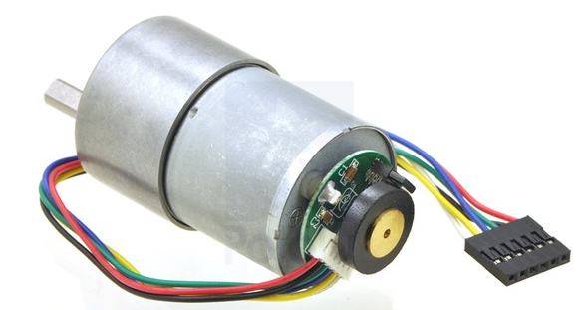
Figure 2: 100:1 Metal Gear motor 37DX57L mm from Pololu Robotics and electronics

- Gear ratio: 100:1
- Free-run speed at 6V: 50rpm
- Free-run current at 6V: 250 mA
- Stall current at 6V: 2500 mA
- Stall Torque at 6V: 110 oz. in
- Free run speed at 12V: 100 rpm
- Free run current at 12V: 300mA
- Stall current at 12V: 5000mA
- Stall Torque at 12V: 220 oz. in
- Lead length: 11in

The Electronic component of the motor is a Pololu Dual MC33926 Motor Drive Shield Arduino Board as seen in the figure below. The Controller can operate from 5 to 28 V. The Arduino Uno R3 board will be able to control the speed of the motor by changing the angular frequency.
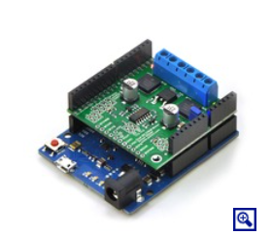
Figure 3: Pololu MC33926 Motor

Waterproof Components Case Design (two components)
The Linear Actuator Arduino Board and the Wave Generator Arduino Board both are exposed to various weather conditions since their operation will mainly be outside. Leaving the equipment open will make it vulnerable to rain and wind and for thing reason, waterproof casing will need to be built. The dimensions for each case depend on the size of the Arduino board and holes will need to be made for the electrical cords to enter and leave. The team decided to create the casing out of plastic based on its benefits of strength, cost and protection from the environment. Below is a general concept for what the casing will look like and further detail of dimensions can be seen in Section 3.1.
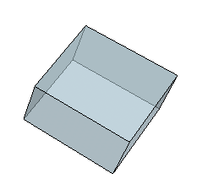
Figure 4: General Waterproof Case Concept

Programming
The electronic equipment components communicate with the Raspberry PI to perform signal processing and analyze the receive signal. The ongoing process of coding from the previous years’ (2012-2013, 2013-2014) project was lost and must be recreated. The design will follow similar designs from the previous years to communicate all portions of the circuit effectively while sampling at 200 KSPS. All programming will be done on the Raspberry Pi Model using HTML, CSS, jQuery, and PHP. The Raspberry Pi will import data from ADC and convert the data into JSON so that some C or C++ (replacing Python script) code can import the data to the MySQL Database.

X-Band System
Once all requirements are met in the C-band system, the team will start projecting ideas for the X-band system. At this level of the project, only low-level research will be going on for the upgrade. When everything is operational, power and frequency calculations will be performed and replacement parts will either be scoped out or ordered in relation to the status of the project.

Subsystem Requirements

Linear Actuator Motion Control
The motion control for the antennas has been discussed in Milestone 1 and 2 and must meet the following requirements:

- The motion of the radar and antenna must have a 30 degree range of motion.
- The desired angle of the antennas will be controlled in the GUI.
- The system must be protected from the environment.
- The antennas must target the wave pool.
- Must be capable of withstanding a load of 150lb

In order to ensure that the system will operate at these requirements, the team will use previous year’s proposed linear actuator Figure 5 and the Pololu jrk 12v3 Arduino Board in Figure 6 based on the calculations. The calculations below were performed to ensure that the linear actuator selected would in fact be able to both achieve the 30$°$ range of motion and control the load of the radar.
Figure 5: Linear Actuator for Antenna Motion Control
Figure 6: Pololu jrk 12v3
The entire system must be able to operate within 12 or 5 Volt rails and be compatible with the Raspberry Pi applications processor, the linear actuator is to be powered via a jrk 12v12. It contains many other built in features that will make the implementation of motion control function. Coding to control the linear actuator will be done using JavaScript, HTML & CCS to create the motion control GUI. The researcher will give an input and the angle will be passed into the motor control function to control the motion and result in a correct angle of the antennas.

Wave Generator
The oscillation control for the wave generator has also been discussed in Milestone 1 and 2 and must meet the following requirements:

The tasks that the wave pool generator will need to handle are as follows:
- The wave pool must be able to generate gravity style waves and/or ripples
- The frequency of the waves generated must range between 0 – 5 Hz
- The waves generated must be 2.8 cm
- The wave pool generator must be controlled from the GUI with the user providing an input frequency.

The previous year created and assembled the wave generator. The team will need to implement the existing design into the system and incorporate its motion into the GUI. The control will be similar to the linear actuator control using pulse width modulation (PWM). The user will input a frequency of desired oscillation and the motor will respond by creating waves in the wave pool to meet the requirements.

Weatherproof Component Chassis
Since the system will be operated outside, it must be able to withstand various weather conditions. The weatherproof case will be used as the housing unit to protect the circuitry of the system. Since the two cases are small and will be made out of the same plastic, only one sheet will need to be purchased. A sheet with a width of 4 feet, a length of 8 feet and a thickness of 1.5’’will be purchased for $28.98. The relatively low cost and its ability to withstand rain makes it the perfect material to use for the design. The case must be big enough to cover both electrical components and have plug-and play capabilities. The square orifice will be reinforced to prevent the water from getting inside the case.

Raspberry Pi
All programming will take place on the Raspberry Pi Model. This specific computer was chosen because every aspect of the computer is open source, it’s less than $40 (provided by last year’s design team), and has 1.2 GHz ARM Processor which is more than enough processing power than we need. The computer will be running Linux, as such all programming must be able to compile and run in this environment.
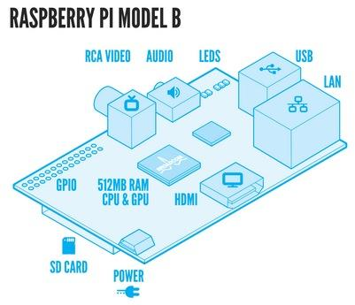

Programming
The team will be adding two new Computer Science students to the project to help in development of the system. These students will assist in coding and recreation of the GUI and database to meet the requirements of the project.

Data Storage
The design team must piece together code from the previous year to recreate the data base and all software and scripts must be able to run in a Linux environment. The end-user GUI was created to allow any user to grab data from the system and view it in a manner that is easy to view and understand. The team will recreate the GUI in this way. Running on an Apache web server, the GUI’s visuals were written in HTML, CSS, and JQuery, with the commands being executed by PHP. Data is stored in a MySQL database where PHP uses built in native functions to pull and push data to the database, which can then be executed from the GUI. All data is taken in a snapshot of sampled data rather than the entire sampled data.

Antenna and Wave Generator Motion Control
There are two sets of code that are needed to work the Antenna Motion Control System and the Wave Generator function properly. For the Antenna Motion Control, the code takes in the X-value of the distance of the wave pool to the antenna. Once this value has been input into the GUI, a calculation will be done to determine the angle needed to set the antennae. The calculated angle will be passed to the motor code and translated to a PWM signal. The PWM will then pass to the motor control which will then move the linear actuator. For the Wave Generator, the code will take in a frequency from 0 to 5 Hz and place it into the GUI. Then, it will be passed into the motor code and translated to a PWM signal and move the wave generator. C language will be used to program the hardware and HTML and JavaScript will be used to make the initial GUI.

Performance Assessment
The design of the overall system was made with the needs analysis and requirements specifications defined in Milestone 1. The entire system can be completed by viewing each subsystem. These include the linear actuator movement, the wave pool generator oscillation, the recreation of the GUI and data base, and the control of the linear actuator and wave generator from the GUI. Each of these subsystems must meet requirements to ensure performance of the whole system. The existing system has been tested and works properly with its electrical circuitry. Any updated components must by compatible with the existing power supplies particular to 5V DC, 12V DC, or 110V AC power. The system must also remain portable and function with its plug-and-play abilities while remaining weatherproof and protected from the environment. While the circuitry will still be plug-and-play, the actual antennas will be attached to the control mechanism and mount approximately 30 ft. above the ground. Because of this, the motion control system is not expected to be portable but its electrical components should be weatherproof. The antennae must be capable of accurately targeting the wave pool with a given horizontal distance between the wave pool and the antenna. The antennae must also be able to withstand the high loads induced upon them during high wind conditions. This has been ensured through the calculations of the linear actuator and will be verified once the final motion control mechanism is assembled.

Design Process
The team has fully examined the existing system and has seen it perform by viewing its results on an oscilloscope. Samples of code from the old system have also been gathered and the process of placing them together has started. The team will need to build the data base and get the data connections in place to ensure the code works properly or begin making modifications. This will be done with the assistance from the new computer science students to ensure there are no simple errors being made and prevent errors from occurring.
Each member of the team is individually assigned tasks so the project can be completed in parallel with other tasks. Each student responsible must oversee the design process of their tasks so the project can come together.
The circuitry, design from linear actuator, and design for the wave generator all need to be recreated from previous years. No parts were scoped out for the project except for the creation of the weatherproof casing. The team will redesign the GUI with the help of the computer science students while keeping the existing sampling rate and design layout from the previous years.

Design of Major Components/Subsystems
The system currently operates on the C-band frequency of 5.4 GHz from last year’s senior design project. In the future, if all other needs are met, the system will be converted to X-band with the same signal processing technique using the mixer component. Ongoing research will continue for the X-band system as other tasks are being completed. This design team will focus on adding mechanical functionality to the system using a linear actuator proposed from last year’s design team, adding functionality to a wave generator to create 2.8cm amplitude waves, waterproofing all electrical and mechanical elements, and creating a Graphic User Interface (GUI) to view the receiver signal, control the wave generator and control the angle of the antennas.

Weatherproof Casing
The goal of the weather proof cases is to protect the electrical components from weather conditions, especially rain and dust which was one of the nonfunctional requirements. To meet this requirement the team will build a cubed shape case with dimensions slightly greater than the size of the Arduino boards. The casing should not be permeable and plastic was chosen for the design. This also meets our requirement for keeping all circuitry portable because plastic is lightweight and easy to manage and easy to transport.

Pololu jrk 12v3
This component is attached to the motor for the linear actuator. The dimensions for the box are 2.5” x 2.5” x 2”. These dimensions give extra room for the plug-and-play abilities and completely seal the component. The box will be able to open so the component can be placed inside and all holes for cabling will be completely sealed with rubber or polyurethane-based insulating foam sealant that fills, air-seals and insulates small gaps.
Figure 7: Weatherproof box Design

Pololu MC33926 Motor
This component is attached to the motor for the wave generator. The dimensions for the box are 4” x 2.5” x 2”. These dimensions give extra room for the plug-and-play abilities and completely seal the component. The box will be able to open so the component can be placed inside and all holes for cabling will be completely sealed with rubber or polyurethane-based insulating foam sealant that fills, air-seals and insulates small gaps.
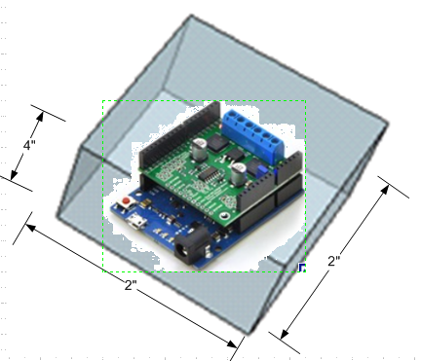
Figure 8: Weatherproof box Design

Linear Actuator Motion Control
The antennas, cabling and mounting equipment have all been obtained for this project. The design team must assemble all parts onto a constructed side arm once all testing has finished. The antennas are currently assembled in the lab on a tripod so testing for the database and linear actuator movement code can be validated. The load induced on the base plate by both the antenna alone along with any wind loads should still meet all requirements and withstand the force. A better visual representation of how the linear actuator will be used to control the motion of the antenna and where the antenna will mount to the base plate can be seen bellow in Figure 9 and a three dimensional view can be depicted in Figure 10.
Figure 9: Conceptual drawing of Linear Actuator Movement

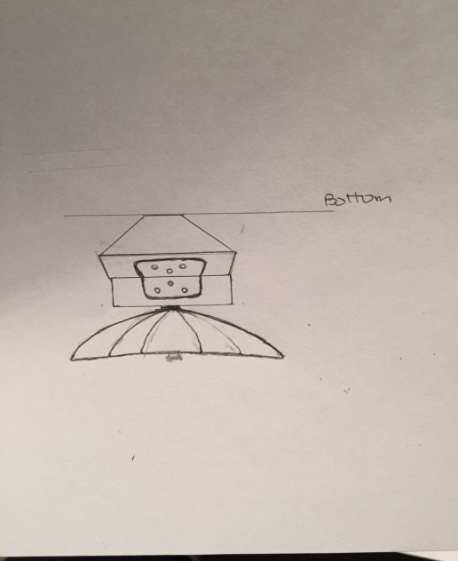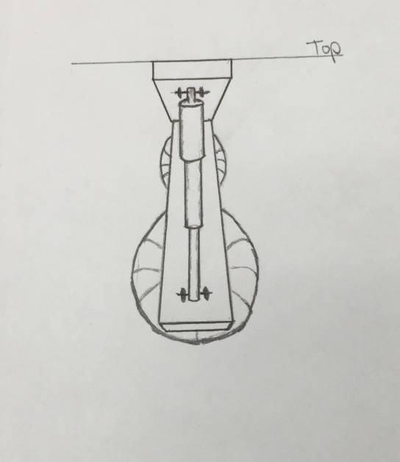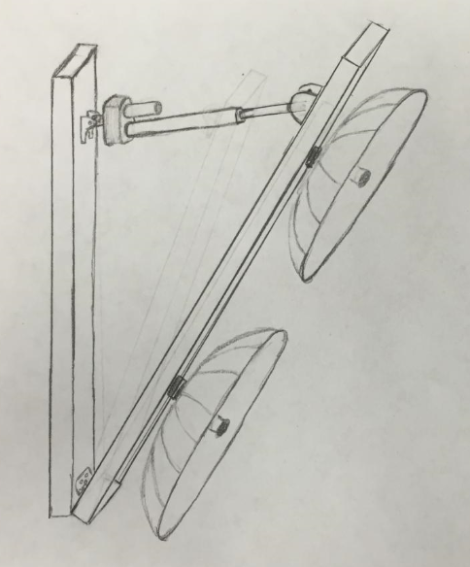
Figure 10: 3D Conceptual drawings of Linear Actuator Movement

Linear Actuator Motion Control Code
All drivers and files will be installed from the Pololu website specific for the Pololu jrk 12v3 motor controller. Once installed, functions will be written to control the motor up to an angle of 30 degrees to move the antennas. JavaScript, HTML, & CSS will be used to create the Motion Control GUI. The GUI (INPUT) will take in an X-value of the distance from the antennae to the wave pool. From there the code will calculate the degree needed for the antennae to be positioned to be aimed at the center of the wave pool. The calculations for the code can be seen in Figure X and Figure X. The angle will then be passed into the motor control function that will take an angle parameter. The motor control component will be written in C and will send a reformatted value to the pulse width modulator (PWM) to control the motor. The motor will then adjust the linear actuator to the angle desired. Seen in the figure below, a block diagram of how the system will operate and a visual of the movement for the antennas in the final simulation with all components assembled. Since the entire system must be able to operate within 12 or 5 Volt rails and be compatible with the Raspberry Pi applications processor, the linear actuator is to be powered via a jrk 12v12 motor driver. This was designed for similar linear actuators. It includes automatic motor driver shutdown on under-voltage, over-current, and over-temperature conditions, as well as many other built in features that will make the implementation of motion control quite easy. The current for each antenna is rated at 50 Ohms with a maximum power of 100 Watts. Refer to the spec sheet in the appendix for more details. The jrk 12v12 motor driver is designed to take a power input of 6-16 Volts. Given the high rail of 12 volts, the linear actuators and the motor drivers (5 volt signal input) will work well together.

Figure 11: Block Diagram for Linear Actuator Code
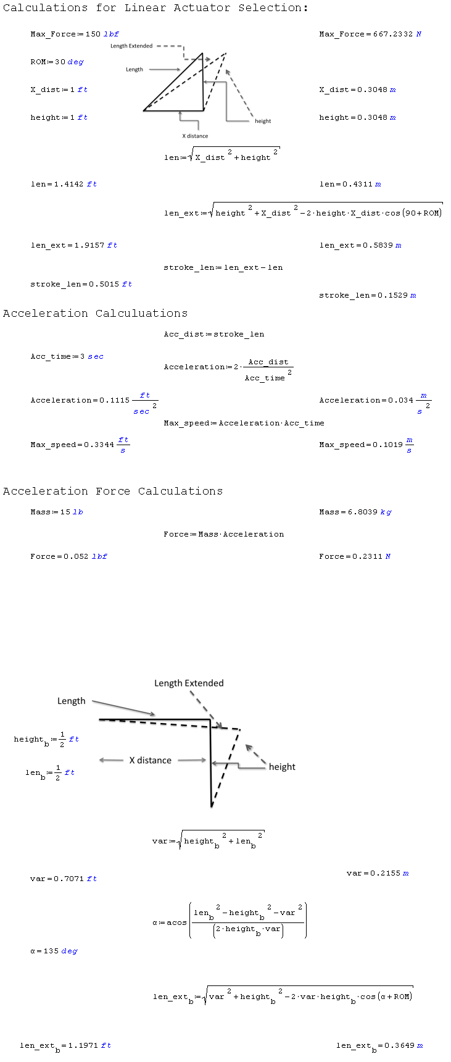
Figure 12: Linear Actuator Calculations

Figure 13: Linear Actuator Calculations

Wave Generator
The motor for the wave generator was also chosen from last year’s project. This year, the team must code the Pololu Dual MC33926 Motor Drive Shield Arduino Board to generate gravity style waves in the wave pool at a specific frequency. The coding process is very similar to the way the linear actuator is embedded into the system as seen in section 3.3. The GUI will take in the frequency as an input. Then the code will be reformatted with the pulse width modular (PWM) to control the oscillation of the motor and generate the waves in the wave pool tank.

Programming
All programming will take place on the Raspberry Pi Development Computer. This specific computer was chosen because every aspect of the computer is open source, it was used by last year’s design team, and has 1.2 GHz ARM Processor which is more than enough processing power than needed. The computer will be running Linux, as such all programming must be able to compile and run in this environment.
All scripts written must be able to run in a Linux environment. The actual user interface will be web based and run on an apache web server with PHP support. All data combined must be less than 14 Gigabytes in size, so a snapshot of the sampling will be done instead of storing all data.
The design team has uploaded pieces of code to the Raspberry Pi shown in the command line below. These are the files of what is being hosted and more will follow as development grows.

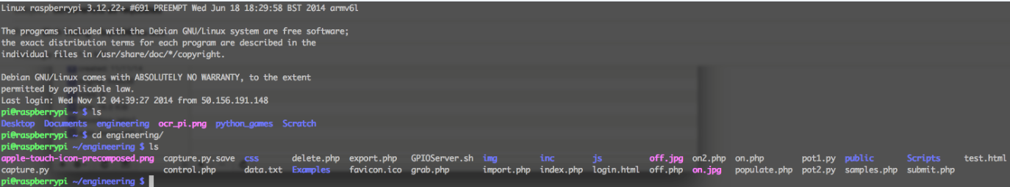

Database
The MySQL database structure was chosen as the default database engine for this project. The database will store all data received from the DSP and be the engine for which the GUI generates its content. MySQL is currently the most used database engine available, and typically considered the standard database engine of the internet.
The design team has started the recreation of the data base. The figure below shows the brackets and code to identify the types of the variables to review in the old code samples for PHP and python. The other figure shows the tables that are currently in MySQL for the data base SeniorDesign.

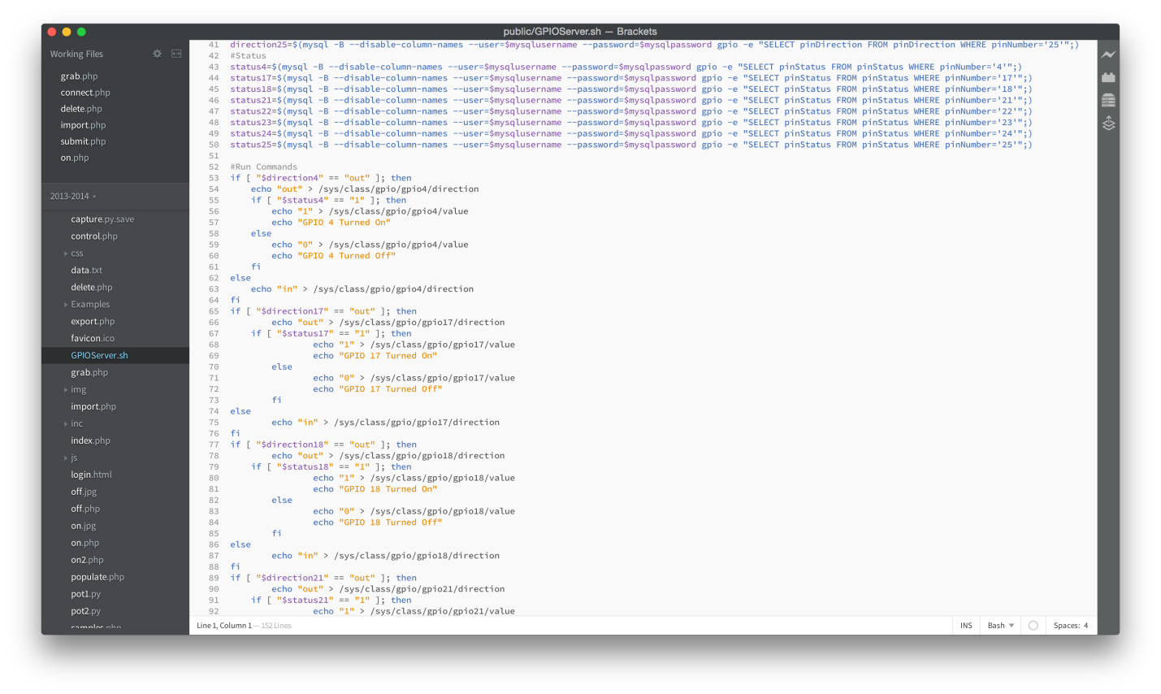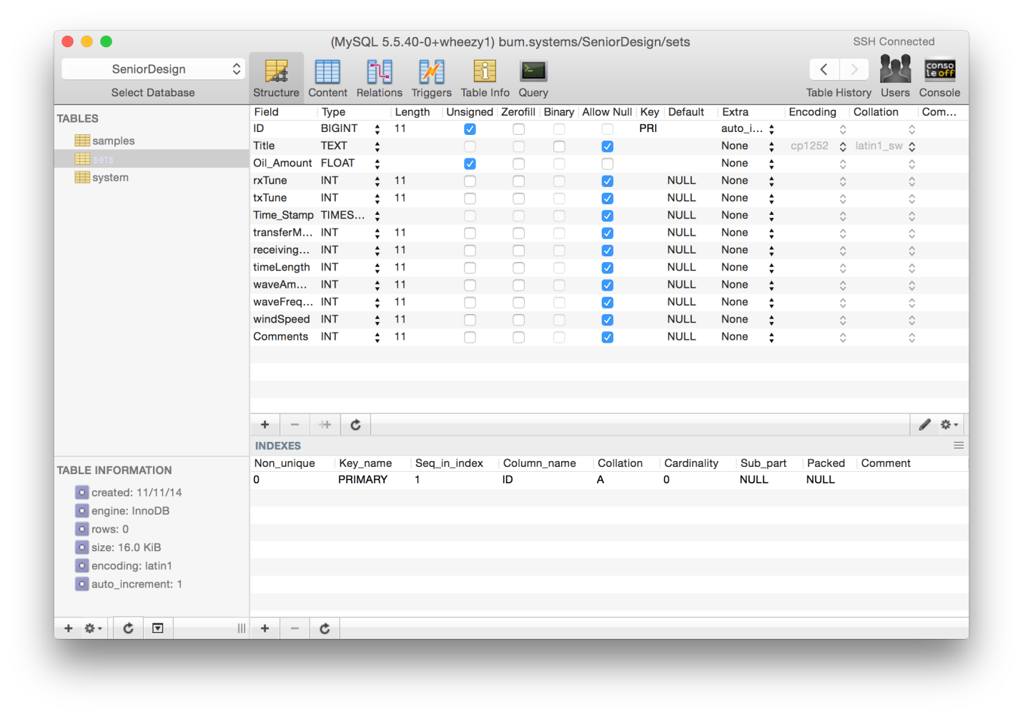

Database Structure
The sampling for the data base comes from the ADC and the chip chosen for the circuit. The samples are the amplitude of the analog signal converted into a string. The id variable is used for database purposes, and will help with storage.

Network Based Graphical User Interface (GUI)
Actual user interaction with the system will take place via a web browser designed from the previous year. The data can be accessed by IP address when locally connected. The GUI will be written in PHP, JQuery, CSS, and HTML using MySQL as the database. This code language was chosen because there is sample code from the previous year to help rebuild the interface. When a user asks the GUI for updates a PHP script will query the database for new entries and return any if there is new data.
The design team has started to piece together the code onto the Raspberry pi and host the database. Files still need to be moved around to the correct locations that the scripts reference but this will be done after preliminary testing. Below is a figure out what the current GUI appears to the user. Testing for data types associated with the tables needs to be done for further implementation.
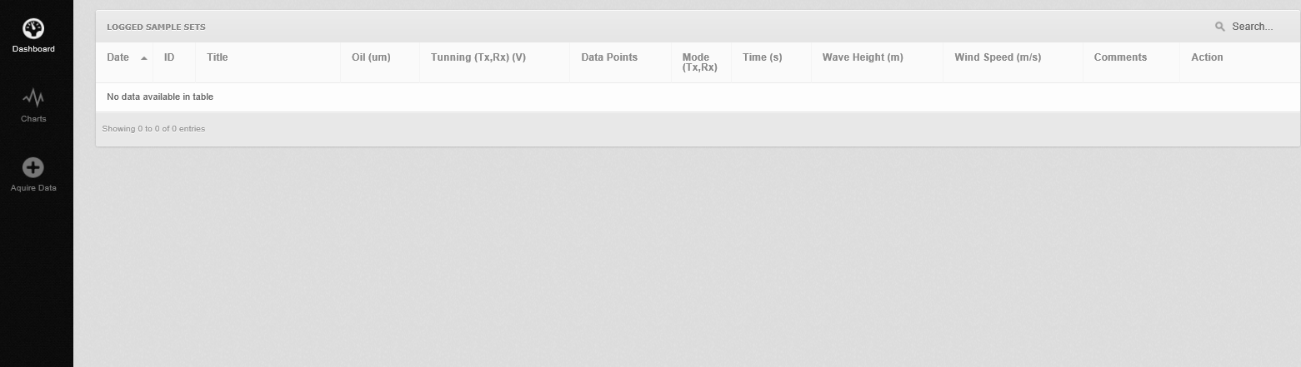

Analyzing the Data (Electromagnetic Waves)
The Radar system is able to function based on reflections of electromagnetic waves propagated through a particular media and their reaching an intersection with a new media. Depending on the intrinsic impedance mismatch of the first media against the second (new media) there will be a certain ratio of the original signal that will be reflected. Since reflections that are directly returned to the radar are the only ones that return useful data, reflections at the normal (perpendicular) will be targeted.
Intrinsic impedance of a particular media is dependent solely on the electromagnetic properties of the media. The electromagnetic properties of the media refer to the permittivity (ε), permeability (μ), and general conductivity (σ). Transmission will occur through three media for the final experimentation of the project: air, oil, and water (all of which classify as a dielectric or weak conductors). As far as the propagation of electromagnetic waves is concerned, air has very similar properties to free space, so characteristics of free space will be used to model the behavior of electromagnetic waves through air.

Table 3.5.1. Various Media and their E and M Properties
 | Air | Petroleum | Tap Water | Saltwater
Conductivity (σ) | 0 (S/m) | ~ 0 (S/m) | 5 - 50 (mS/m) | 4 (S/m)
Relative Permittivity (ε_{r}) | 1 (V/m) | 2.1 (V/m) | 80 (V/m) | 80 (V/m)
Relative Permeability (μ_{r}) | 1 (H/m) | 1 (H/m) | 1 (H/m) | 1 (H/m)

The inclusion of two types of water is to show that (after calculations) there is only a slight difference in both of the intrinsic impedances. This finding demonstrates that they are generally interchangeable as far as the testing purposes of the project are concerned.
The next step in understanding the ratios of transmission versus reflections between these media is to calculate the intrinsic impedance for each of the media. The magnitude of intrinsic impedance (ή) can be calculated using the following equation
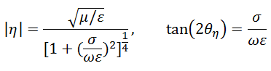
Equation 3.5.1 Intrinsic Impedance Magnitude and Phase

The frequency used for omega is the chosen transmission frequency of the system (5.4GHz). Θη is the phase of the impedance. The following is a table of the intrinsic impedance for each of the previously discussed media.
Table 3.5.2 Various Media’s intrinsic impedances
 | Air | Petroleum | Tap Water | Saltwater
η (Ω) | 377 | 259.971 | ≈42.1084∠.03 | 40.5298∠4.72

The intrinsic impedance to the reflection coefficient (Γ) and the transmission coefficient that (τ) are related in the following equation.
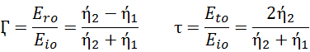
Equation 3.5.2 Intrinsic Impedance to the Reflection Coefficient

The above equations directly compare the intrinsic impedance of two media. This allows the solution to quantify a signal arriving at a normal to a media intersection to be found. These intersections in particular are air to water, air to oil, and oil to water. Each coefficient will be expressed as a percentage.

Table 3.5.3 Reflection and transmission coefficients
Media Intersection | Γ (reflection) | τ (transmission)
Air to Water | 80.5859 % | 19.4141%
Air to Oil | 20.5695% | 79.4393%
Oil to Water | 71.0047% | 28.9245%

Aside from just detection of the oil/emulsion that will be dispersed atop the water, a measure of how thick the top layer substance must be acquired via the measurements that the radar system can collect. The experimentation done with this system will see differentiating layers of oil/emulsion over the water from test to test. The thickness will vary and that loss of the transmitted signal from air to oil/emulsion will encounter attenuation through the length of the layer. The signal will eventually meet the intersection of oil/emulsion and water and, according to the reflection transmission chart, will again be reflected back through the emulsion layer. 70% of the signal that reaches the intersection will be reflected back and be re-attenuated as it passes through. Only 80% that actually reaches the oil/emulsion and air intersection will pass through and reach the radar. It is possible for multiple reflections to occur within the emulsion layer. Each one will be subject to the same reflection and transmission coefficients previously described, reducing the signal at each intersection. This observation leaves the first signal to return from the oil/emulsion layer to be the most significant one, as it will dominate the added power received from the first initial top layer reflection. A visual diagram of the Multilayer interactions that are expected to occur and the equation for the attenuation factor for any particular media follows.
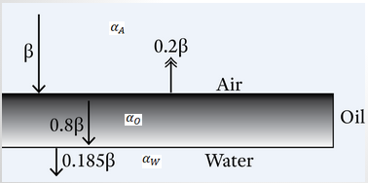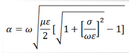
Figure 3.5.1 Reflection Coefficient of Media

Taking into account the attenuation and knowing the reflection coefficient at each media, the thickness of the oil/emulsion can be calculated by subtracting the initial surface reflection from the final value actually received. The remaining power will be the power returned to the radar system after the inner reflection of the emulsion layer. As the signal is attenuated twice by the factor alpha and reduced by 30% at the oil water intersection, the depth of the emulsion layer can be derived.

Schedule

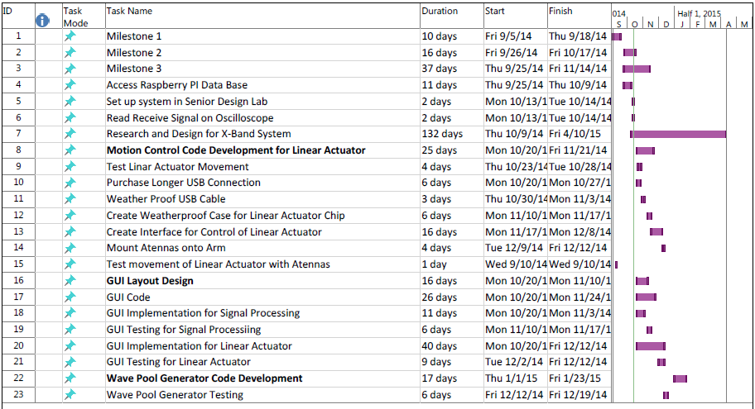
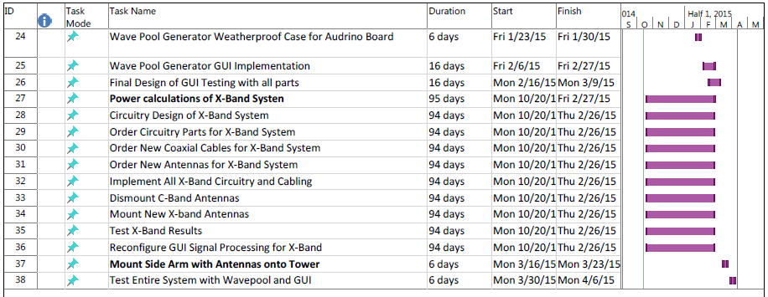

Responsibilities
The following is a table of member responsibilities.
Task Name | Engineer Assigned
Milestone 1 | 1,2,3,4
Milestone 2 | 1,2,3,4
Milestone 3 | 1,2,3,4
Access Raspberry PI Data Base | 1,2
Set up system in Senior Design Lab | 1,2,3,4
Read Receive Signal on Oscilloscope | 1,2,3,4
Research and Design for X-Band System | 2
Motion Control Code Development for Linear Actuator | 4
Test Linear Actuator Movement | 1,2,3,4
Purchase Longer USB Connection | 3
Weather Proof USB Cable | 4
Create Weatherproof Case for Linear Actuator Chip | 1,4
Create Interface for Control of Linear Actuator | 2,4
Mount Antennas onto Arm | 1,2,3,4
Test movement of Linear Actuator with Antennas | 1,2,3,4
GUI Layout Design | 1,2
GUI Code | 1,2
GUI Implementation for Signal Processing | 1,2
GUI Testing for Signal Processing | 1,2,3,4
GUI Implementation for Linear Actuator | 1,2,4
GUI Testing for Linear Actuator | 1,2,3,4
Wave Pool Generator Code Development | 2,3
Wave Pool Generator Testing | 1,2,3,4
Wave Pool Generator Weatherproof Case for Arduino Board | 1,3
Wave Pool Generator GUI Implementation | 2,3
Final Design of GUI Testing with all parts | 1,2,3,4
Power calculations of X-Band System | 2
Circuitry Design of X-Band System | 2
Order Circuitry Parts for X-Band System | 2,3
Order New Coaxial Cables for X-Band System | 2,3
Order New Antennas for X-Band System | 2,3
Implement All X-Band Circuitry and Cabling | 1,2,3,4
Dismount C-Band Antennas | 1,2,3,4
Mount New X-band Antennas | 1,2,3,4
Test X-Band Results | 1,2,3,4
Reconfigure GUI Signal Processing for X-Band | 2
Mount Side Arm with Antennas onto Tower | 1,2,3,4
Test Entire System with Wave pool and GUI | 1,2,3,4
Key
Engineer | Label
Eva Ulibarri | 1
Stephanie Anderson | 2
Joel Watson | 3
Omonayo Bolufawi | 4

Budget Estimate
Assume the following for the Budget estimates
- Each engineer gets paid $30 per hour
- The total pay is based off of two 15 week semesters
- Fringe rate on all personnel is 29%
- Overhead rate is 45% of the direct costs

Engineers | Billable Hours | Hourly Pay | Total Pay
Eva Ulibarri | 360 | $30.00 | $10,800.00
Stephanie Anderson | 360 | $30.00 | $10,800.00
Joel Watson | 360 | $30.00 | $10,800.00
Omanayo Bolufawi | 360 | $30.00 | $10,800.00
Personnel subtotal |  |  | $43,200.00
Fringe Benefits |  | 29% of Personnel subtotal | $12,528.00
Total Pay |  |  | $55,728.00

Expenses
Items | Quantity | Per Unit | Total Price
Extension of USB Cable | 1 | $10 | $10
Plastic for Weatherproof Boxes | 1 | $28 per sheet | $28
 |  | Expenses Total | $38
Total Direct Costs |  | (Personnel + Expenses) | $55,756
Overhead Costs |  | 45% of Direct Costs | $25,090.20
Total Budget
Total Project Cost |  |  | $80,846.20

Overall Risk Assessment

Technical Risks

Technical Risk 1: Software Failure
Table 6.1.1.1 Software Failure Risk
Risk | Software Failure
Description | Software failure is very likely as there are numerous coding components to the project. These components include the database GUI, acquisition of data from the ADC, GUI for the motion control system, and motor control code.
Probability | Moderate
Consequences | Catastrophic
Strategy | Conduct testing and debugging throughout every stage of the project and ensure proper interfacing occurs at each step. If the GUI is not accessible, the team will need to hard code calculations for the appropriate position of the antennas and also the angular frequency of the wave generator.

Technical Risk 2: Mechanical Failure

Technical Risk of Antenna Motion Control
Table 6.1.2.1.1 Mechanical Failure Risk
Risk | Mechanical Failure
Description | The main technical risk associated with the antenna motion control would be the power requirements. The linear actuator operates on the upper limits of our power supply rails.  Another source of technical risk for the antenna motion control is the force induced on the antenna due to wind and weight of the antenna
Probability | Moderate
Consequences | Catastrophic
Strategy | Care must be taken to ensure that the rest of the system’s circuitry is protected in case of a malfunction or unexpected high current or voltage draw. Load testing the motion system should be done before attaching each antenna.

Technical Risk 3: Electrical Failure
Table 6.1.3.1 Electrical Failure
Risk | Electrical Failure
Description | There are multiple electrical components that are relied upon to make the system work. The biggest issue is ensuring that there is enough power to drive the system. Problems that could occur would be circuit elements being damaged due to high current spikes.
Probability | Moderate
Consequences | Serious
Strategy | Order extra parts for components that could easily be damaged, therefore if something is not working from the circuitry, it could be replaced. The team should also make sure any terminals are connected correctly.

Technical Risk 4: Oil Hazard
Table 6.1.4.1 Oil Hazard
Risk | Oil Hazard
Description | The team is handling oil and emulsions so care must be taken to ensure all oil is disposed and handled properly so as not to damage the environment or living beings.
Probability | Low
Consequences | Serious
Strategy | All safety requirement detailed out by the Hazardous Materials department shall be followed in order to insure safe handling of the oil during testing.

Technical Risk 5: Technologies or Devices Not Completely Understood
Table 6.1.5.1 Not Understanding Technology
Risk | Technologies or Devices not Completely understood or assessed
Description | Not completely understanding the technologies used in the project could be detrimental to the project due to improper handling of equipment.
Probability | Moderate
Consequences | Serious
Strategy | Do research on the particular device or ask another team who may have a better understanding of such device. Students should access previous manual of design project if no other option is available.

Technical Risk 5: Access to Antenna Data
Table 6.1.5.1 Access to Antenna Data
Risk | Data Acquisition Failure
Description | The acquisition of data from the Raspberry Pi GUI will explain the readings received from the antennae. If the Raspberry Pi is not receiving a signal from the antenna, it is impossible to compare the properties of water to any dilution within the wave pool.
Probability | Moderate
Consequences | Catastrophic
Strategy | The team should check for proper focus of the antennas into the wave pool. Also, the Raspberry Pi needs to properly attached to the antennas with the correct LED lights blinking before any signal can be sent or received.

Technical Risk 5: Graphical User Interface (GUI) Failure
Table 6.1.5.1 Access to Antenna Data
Risk | Data Acquisition Failure
Description | The acquisition of data from the Raspberry Pi GUI will explain the readings received from the antennae. If the Raspberry Pi is not receiving a signal from the antenna, it is impossible to compare the properties of water to any dilution within the wave pool.
Probability | Moderate
Consequences | Catastrophic
Strategy | The team should check for proper focus of the antennas into the wave pool. Also, the Raspberry Pi needs to properly attached to the antennas with the correct LED lights blinking before any signal can be sent or received.

Schedule Risk
When working in a group, it is important for the whole team to agree on a designated time and place to meet. An established meeting time is important in that each member can share any difficulties in a task. Also collaboration can be made for the final product. It is important to keep a regular schedule to ensure that members are not confused by inconsistent or sporadic meetings. Students have an ample amount of dwellings to work in so the setting should not be a problem. There is always a potential risk that the designated meeting area has been taken, so a backup location is an acceptable plan of solution. Group and individual deadlines should be addressed at the beginning of each meeting so procrastination won’t be an option. To maintain an efficient timeline of events throughout the project, students will follow the Gantt chart accordingly and assign other task if extra time becomes available.
There is also a risk of conflict in scheduling when members have additional exams to take care of in separate classes. It is critical to schedule time outside of the appropriated meeting time in case there is a need in other classes. The group can meet in smaller groups if other members are unavailable as long as proper notes are recorded for the rest of the members.

Schedule Risk 1: Component Shipment Times
Table 6.2.1.1 Component Shipment Times
Risk | Component Shipment Times
Description | Because senior design is limited to two semesters, it is crucial to choose components for the system that will be able to be delivered on time. If specific components cannot be retrieved in a timely manner, problems will arise.
Probability | Low
Consequences | Catastrophic
Strategy | The team will try their best to order components early when needed.

Schedule Risk 2: Schedule Conflicts
Table 6.2.2.1 Schedule Conflicts
Risk | Schedule Conflicts
Description | To be able to efficiently run meetings, all team members must be present. Currently the team has full schedules, so there are designated, specific times that everyone can meet.
Probability | Low
Consequences | Moderate
Strategy | Create a group calendar to find common time to meet, and assign different tasks to be completed by different members

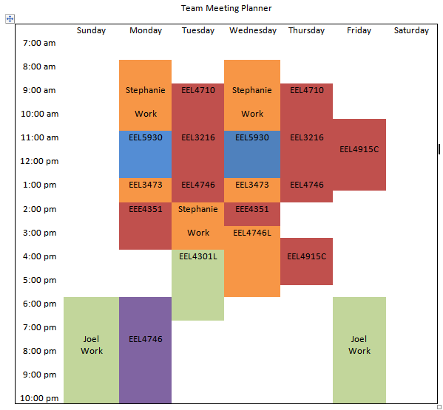
Legend
Eva Ulibarri
Joel Watson
Omanayo Bolufawi
Stephanie Anderson
More than 1 student in class

Figure 6.2.2.1 Weekly Member Schedules

Schedule Risk 3: Unfortunate Events
Table 6.2.3.1 Unfortunate Events
Risk | Unfortunate Events (Car Accident, death or sickness in the family)
Description | In addition to having a tight schedule, sometimes unfortunate events can occur that would prevent a group member from making a meeting. Excusable situations would be a car accident, death or sickness in the family, or personal illness.
Probability | Low
Consequences | Serious
Strategy | Make the team aware of the situation immediate to find ways to proceed with the project. Any missed meeting due to an unfortunate event will not be counted against the student as long communication is maintained.

Schedule Risk 4: Resourcing Risk
Table 6.2.4.1 Resourcing Risks
Risk | Resourcing Risk
Description | Due to the economy, shifts could arise that could make products increase in price or disappear altogether.
Probability | Moderate
Consequences | Serious
Strategy | Order all components early to ensure availability and best prices, do a well-defined estimate to not under buy any resource, and use all resources wisely.

Budget Risks
The budget is critical in planning the development of the project. The project’s budget should not exceed the allotted amount to ensure the sponsor is satisfied. To ensure that the project is successful, the team must display a working C-band radar system before any commitment to developing an X-band system is taken. A repertoire of all parts needed to create the C-band system should be developed to ensure multiple parts aren’t ordered. As this is an on-going project many of the items have already been purchased through previous design groups. This report will eliminate any accidental purchases. To minimize any other budget issues, the team should work to buy quality products at an affordable price, keep a detailed record of all purchases. In case additional funds are needed, the College of Engineering will have funds available upon request within the allotted budget.

Budget Risk 1: Technologies or Devices Not Completely Understood
Table 6.3.1.1 Technologies Understood
Risk | Technologies or Devices not Completely understood or assessed
Description | If technologies or devices are not completely understood, it is reasonable to assume that too many parts could be ordered, wrong components, etc. that could cause the budget to be exceeded.
Probability | Moderate
Consequences | Catastrophic
Strategy | Do research on the particular device or ask another team who may have a better understanding of such device.

Budget Risk 2: Incompletely Identified Requirements/Constraints
Table 6.3.2.1 Incomplete Identified Requirements
Risk | Incompletely identified requirements or constraints.
Description | If the requirements or constraints happen to be incompletely identified, it could cause a strain on the budget. The reason for this is that parts could potentially not get ordered in time, meaning expedited shipping would have to be ordered, new parts, etc. that could cause the budget to be exceeded.
Probability | Low
Consequences | Catastrophic
Strategy | Keep a constant line of communication with the sponsor to get clarification on any requirements and capabilities throughout the whole project. If new constraints are required, the team needs to appropriate these changes into the design immediately to ensure implementation and the satisfaction of the sponsor.

Budget Risk 3: Under Budgeting
Table 6.3.3.1 Under Budgeting
Risk | Budget
Description | Under budgeting could be a problem because it might hint that cheap or not-quality products were used to build the system or there were insufficient funds to build and implement such a design.
Probability | Low
Consequences | Serious
Strategy | Evaluate the overall cost of the project, try to buy quality products at minimum price, keep track of all purchases, and refrain from purchasing stuff that’s not important to the project.

Summary of Risk Status
Though risks aren't guaranteed, they may possibly occur. Therefore it's in the best interest of the team to be realistic and think about possible risks in other to manage or even prevent them. The main risks likely to occur for this project are software failure of GUI and inability to acquire the data from the antennas. These are also the most important due to observation coming from this data acquisition system. With planning and confidence, the team should overcome any unexpected issues that could occur throughout the course of this project.

Conclusion
The design team for Team#3 Oil Spill Radar has defined the needs and requirements set forth by the sponsor, proposed possible designs and a schedule of work to satisfy the needs and requirements, and narrowed down possible designs to a complete system level design to ensure that all needs and requirements are met. The Milestone 3 report focused on the overall design of the system and tasks that need to be carried out through the rest of the year. The system components and designs that were proposed include the linear actuator motion control, wave generator control, data base design, GUI design, code development and overall system-level tests. The scoped out linear actuator meets all requirements through calculations and will satisfy a 30 degree range of motion. The process the make it function will take multiple attempts of debugging but the design team is confident it will work. The Wave Generator system will be able to generate waves of 2.8 centimeters in height (trough to peak) with frequencies ranging between 0-5 Hz. The generator will be able to produce waves in the longitudinal direction at the accurate frequency.
Keeping the sampling rate of 200KSPS, the team will recreate the Graphical User Interface that last year’s design team developed using HTML, JavaScript, and PHP. The code will run on an Apache web server, and be able to be accessed by local users. The Raspberry PI will store the data and run the scripts needed to implement the design. The data base will collect screenshots of data and will be able to be saved for references.
Taking into account the attenuation and knowing the reflection coefficient of each media, the thickness of the oil/emulsion will be calculated by subtracting the initial surface reflection from the final value actually received. The remaining power will be the power returned to the radar system after the inner reflection of the emulsion layer. As the signal is attenuated twice by the factor alpha and reduced by 30% at the oil water intersection, the depth of the emulsion layer can be derived. Using the following information, the team will be able to perform experiments and gather information on the volume of oil present in the wave tank.
With any project, there are risks. With ample planning and preparation, the team is confident that any unexpected issues can be sufficiently overcome. The team will be successful in all aspects of the design project by following the completed deliverables and working closely as a team and with the advisers and sponsors. The amount of detail and research put forth will ensure that all of the team’s requirements are met.

References
[1] "Pololu Dual MC33926 Motor Driver Shield for Arduino." Pololu Dual MC33926 Motor Driver Shield for Arduino. Web. 16 Oct. 2014. <http://www.pololu.com/product/2503>.

[2] Aguero, Manuel, Molus Marcelus, William Munch, Clifton Rice, Nolan Topey, and Nazarelle Vanputte. "Radar System for Oil Spill Analysis." EEL4911C Senior Design Milestone 3 (2013) (2013): 1-65. Print.

[3] Pololu, Kevin. "Pololu/dual-mc33926-motor-shield." GitHub. 6 June 2012. Web. 16 Oct. 2014.

[4] Logan, Jonathan, Juan Alvarez, Andrew Hale, and Roman Cooks. ECE Senior Design Project II. N.p.: n.p., n.d. DOCX.

[5] “MCP3008 - 8-Channel 10-Bit ADC With SPI Interface." adafruit Industries. Adafruit. Web 16 Oct 2013. <http://www.adafruit.com/products/856#Description>

[6] “Stepper Motor Guide Anaheim Automation” Stepper Motor Guide. Anaheim Automation. Fri, 11, Oct. <http://www.anaheimautomation.com/manuals/forms/stepper-motor-guide.php>

[7] “Understanding the IP (Ingress Protection) Ratings of iButton Data Loggers and Capsule” APPLICATION NOTE 4126, Maxim Integrated. Fir, 11, Oct. <http://www.maximintegrated.com/app-notes/index.mvp/id/4126>

[8] “Synthetic Aperture Radar Marine User’s Manual” SarUsersManual, Sar Uses Manual Index. Fri, 07, Oct. <http://www.sarusersmanual.com/>

[9] “Synthetic Aperture Radar Marine User’s Manual” SarUsersManual, Sar Uses Manual Index. Fri, 07, Oct. <http://www.sarusersmanual.com/>

